Foundations Track
AI Foundations for Practitioners
Student Handbook
A technical on-ramp to modern AI for anyone starting to build

Course code | FND-101
Level | Foundational (100)
Length | 1 day (5 modules)
Audience | Developers, engineers, and technical staff new to AI



FND-101 is the foundational, or 100-level, entry point to the training catalogue. Its purpose is narrow and deliberate: to give practitioners who are new to AI an accurate mental model before they attempt the intermediate and advanced material. The course assumes general technical or software familiarity but no machine-learning background.

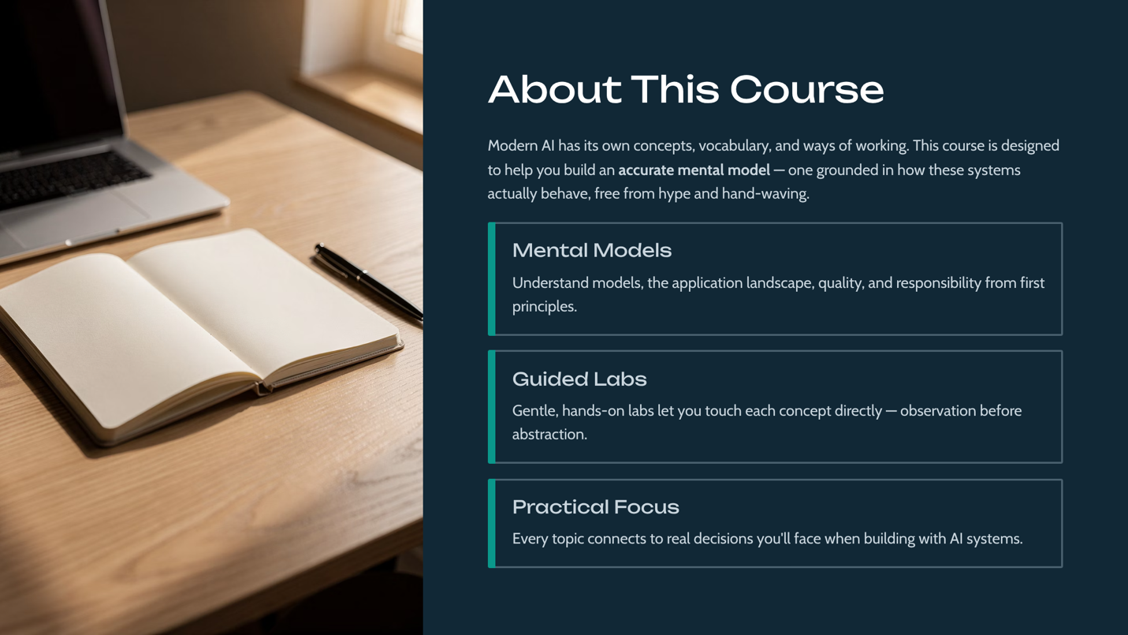

The course is designed to prevent a common failure mode: learning fundamentals and specifics at the same time, which leaves practitioners with shaky foundations. By separating the groundwork into its own day, students enter later courses ready to focus on depth. The stated emphasis on understanding over hype is a deliberate stance — the course actively works to dispel misconceptions rather than add to them.



The audience is intentionally broad within the technical population. The prerequisites are minimal by design, since this is the on-ramp. The one non-technical prerequisite — a willingness to question hype — is emphasized because uncritical acceptance of AI marketing claims is one of the biggest obstacles to reasoning clearly about the technology.

These are the course-level outcomes. Each corresponds to one module, giving the day a clear one-to-one structure. They are phrased as capabilities — what the student can do — rather than topics covered, consistent with the outcome-based design used across the catalogue.

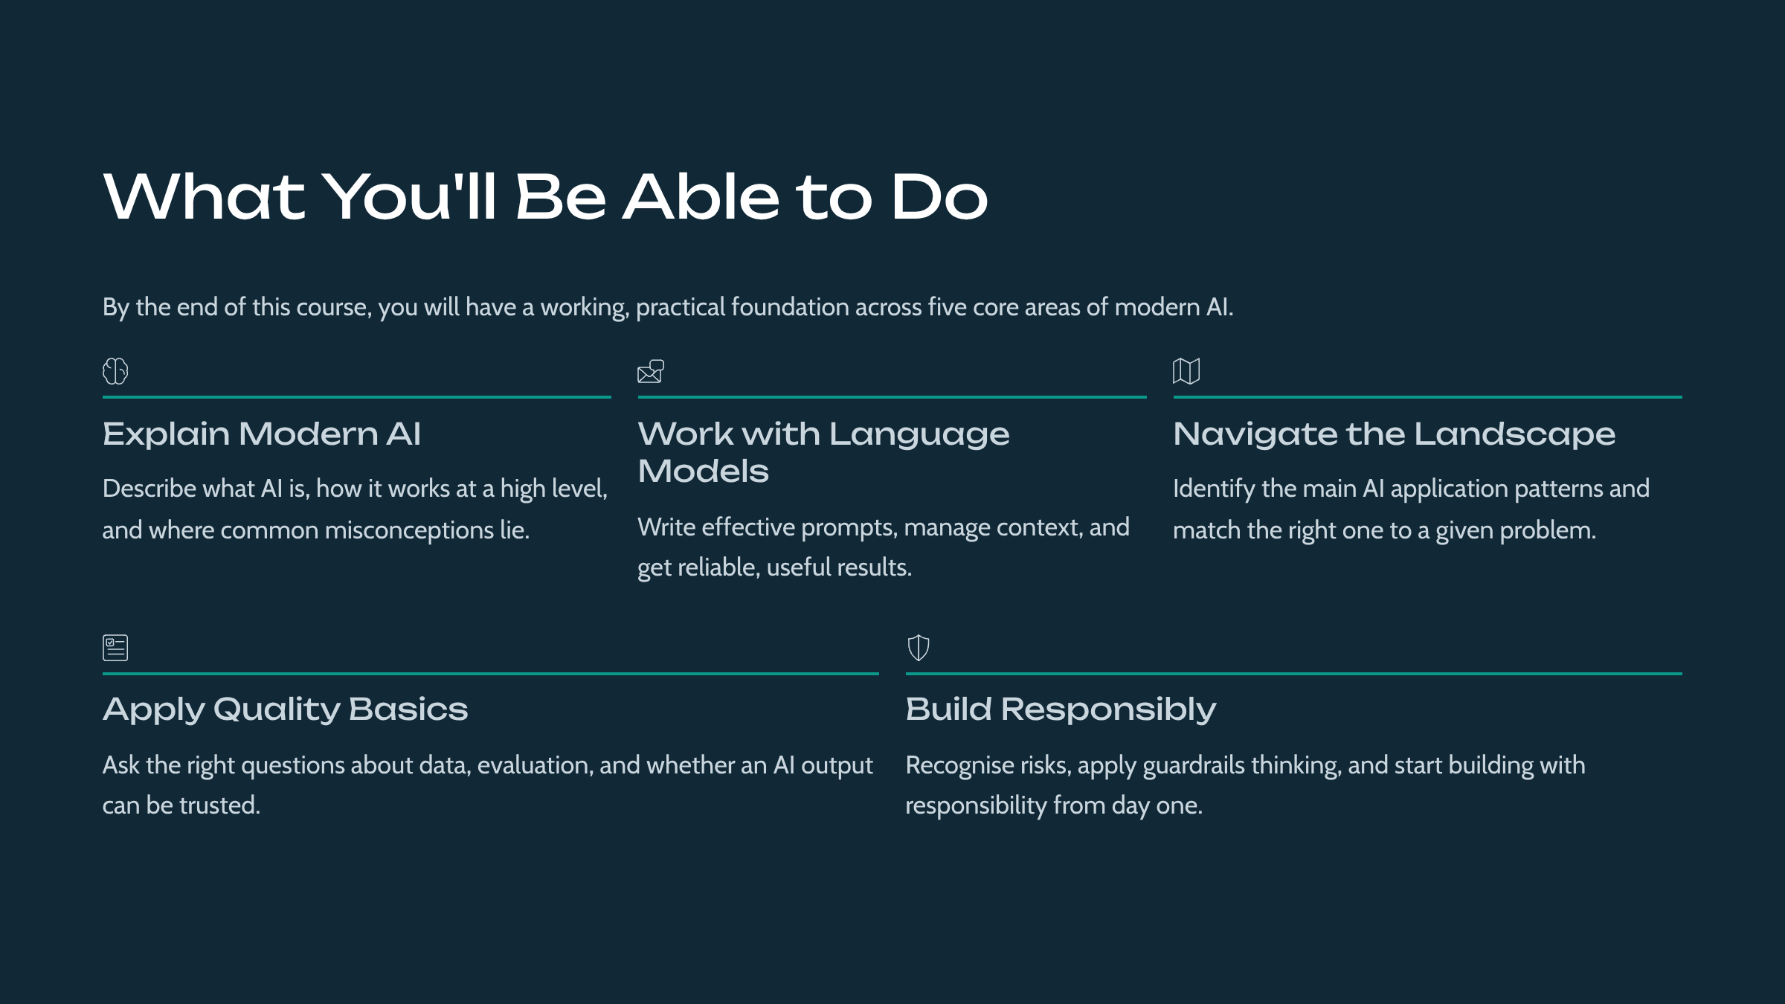

The outline follows a natural progression: from understanding (Module 1), to practical interaction (Module 2), to orientation (Module 3), to quality thinking (Module 4), to responsibility (Module 5). Each module contains five lessons and a hands-on lab, following the Microsoft Official Curriculum style used throughout the catalogue.

Module 1: What Modern AI Is and How It Works

This module builds an accurate, jargon-free mental model of modern AI: what models are, what training does, and why they behave the way they do. You'll learn enough of how it works to reason about it, without needing the mathematics.

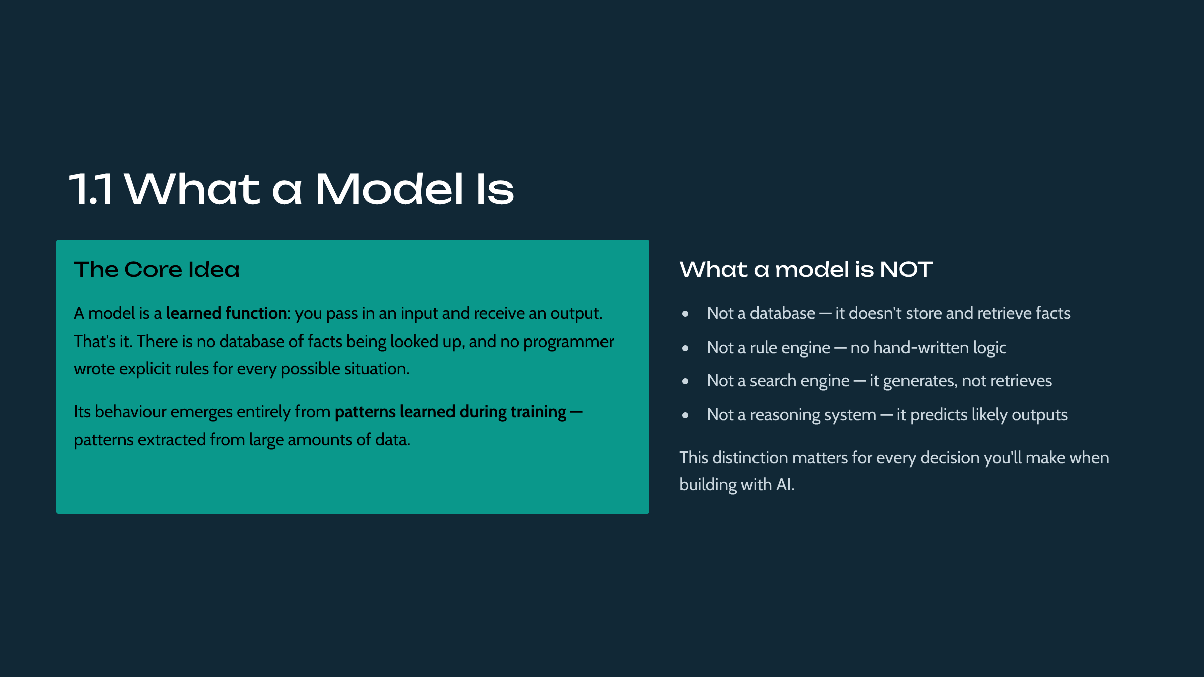

A model is best understood as a learned function that maps inputs to outputs. The critical distinction for newcomers is that a model's behaviour is not explicitly programmed; it emerges from patterns in training data. This is why models can handle inputs their creators never anticipated — and also why their behaviour cannot be fully specified in advance.

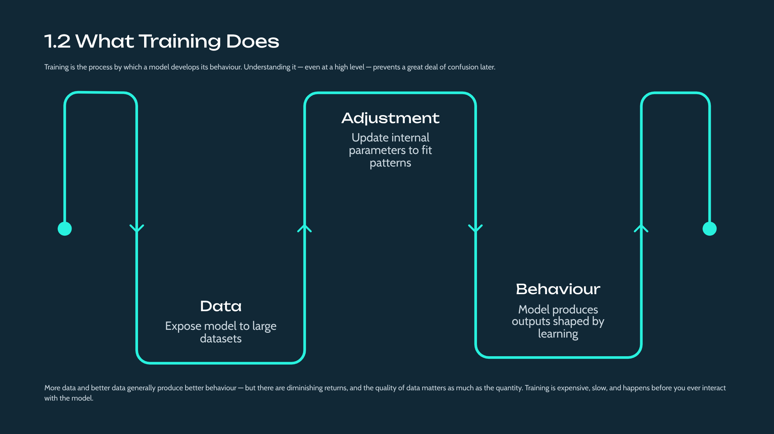

Training is the process by which a model's internal parameters are adjusted to fit patterns in data. No mathematics is required to grasp the essential idea: the model is repeatedly shown examples and tuned until its outputs align with them. The quality and representativeness of the training data largely determine the model's behaviour, which is why data quality becomes a recurring theme in Module 4 and beyond.

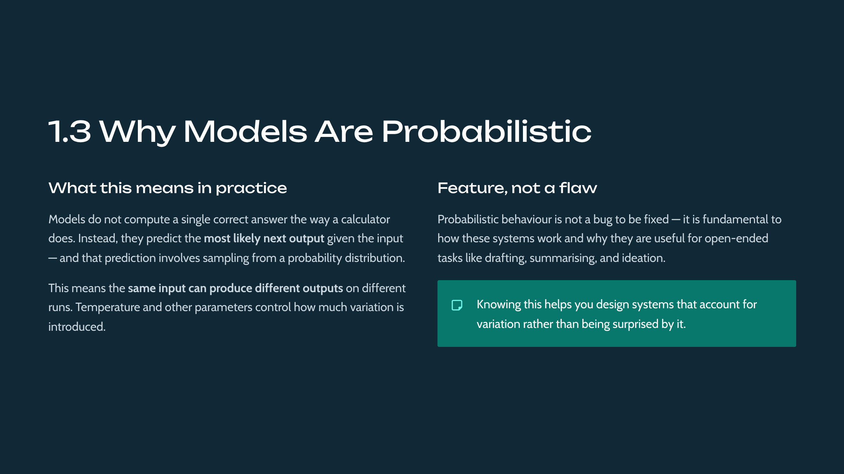

This lesson introduces the single most consequential property of modern AI: it is probabilistic. Models predict likely outputs rather than computing deterministic answers, so identical inputs may yield different outputs. Understanding this reframes many downstream topics — why evaluation is hard, why guardrails are needed, why product requirements must change — and it is worth dwelling on until it feels natural.



A great deal of confusion about AI stems from attributing human qualities to it. This lesson explicitly separates reality from myth: models do not understand, intend, or believe, and their fluency can mask serious errors. This calibration — neither over-trusting nor dismissing — is a core goal of the foundational course and directly supports the healthy skepticism developed in Module 4.

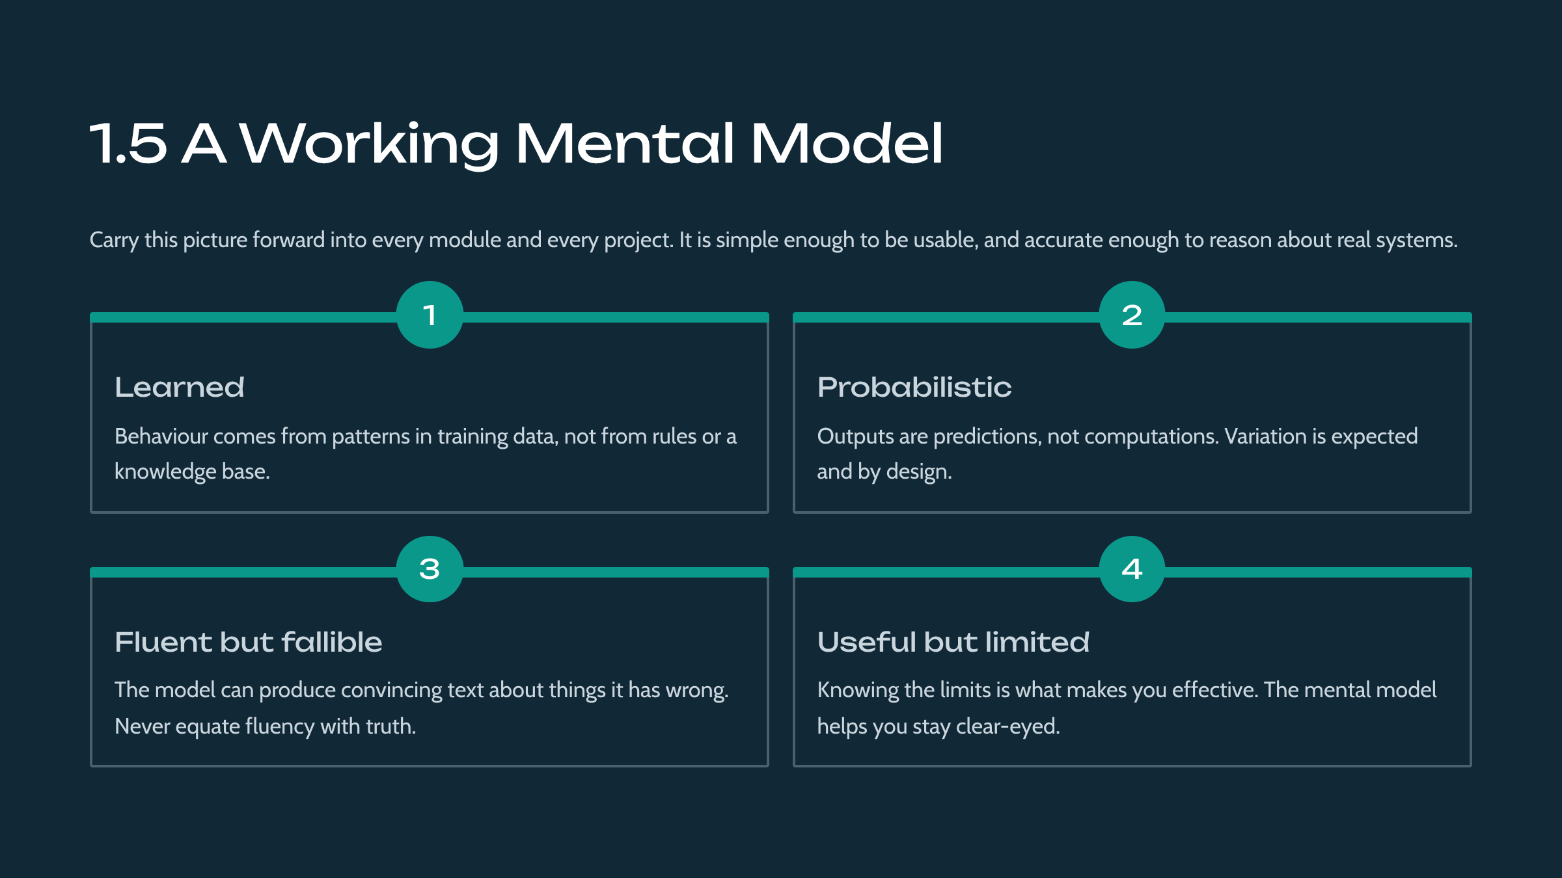

The module culminates in a compact mental model that students carry forward: AI as a learned, probabilistic, data-shaped function that is fluent but not understanding, and useful but fallible. This model is deliberately simple yet accurate, and every subsequent course builds on it without contradicting it.

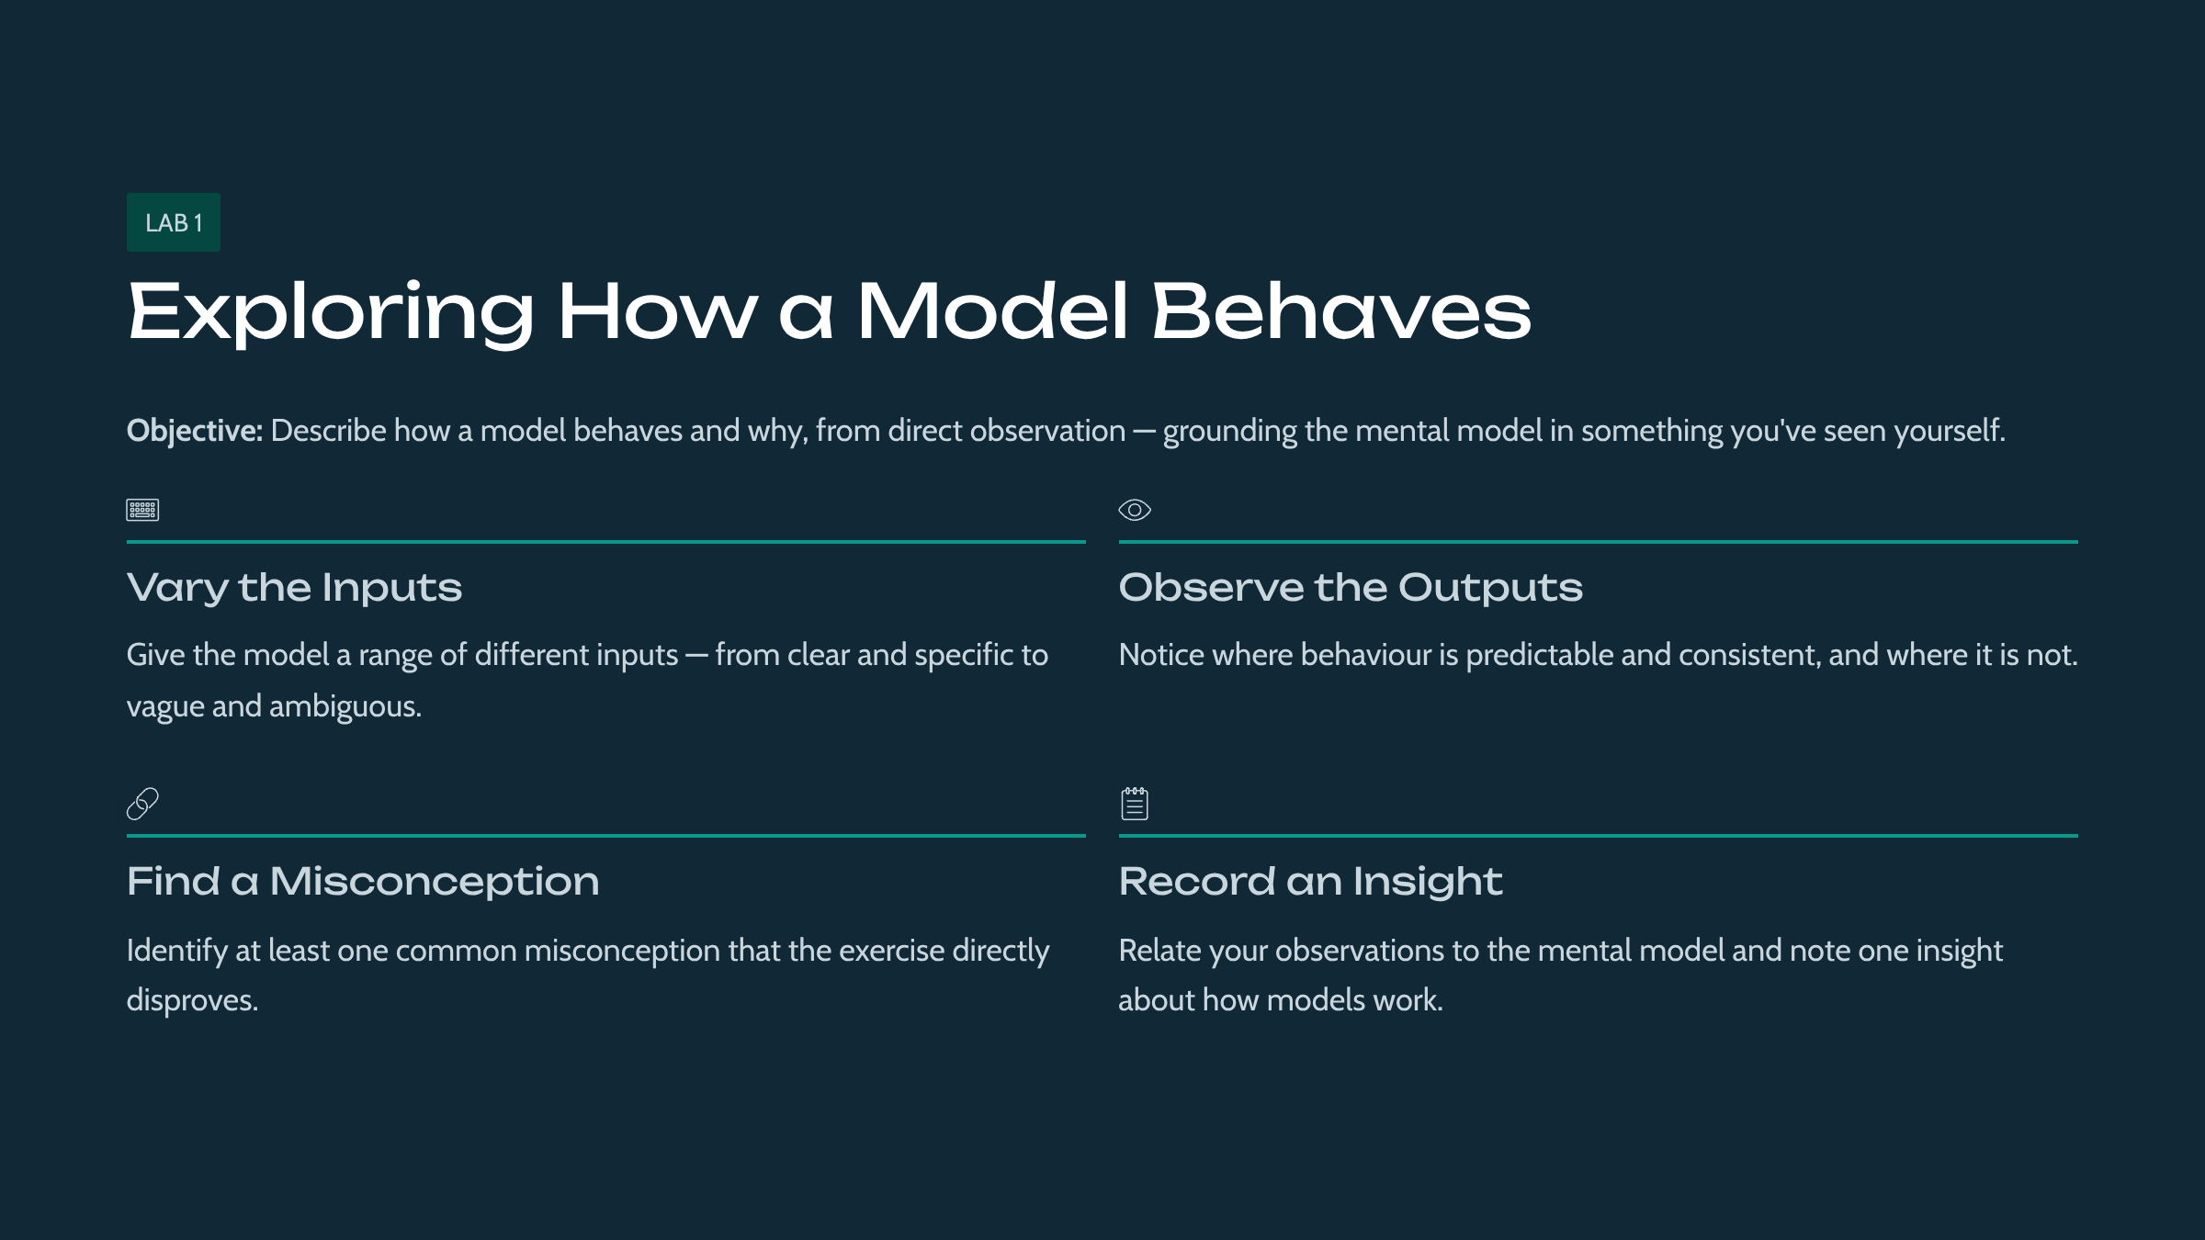

This lab gives students hands-on contact with the module's ideas. Students interact with a model through guided exercises to observe firsthand how it behaves and why. The detailed procedure is in the accompanying Lab Manual.

Module 2: Working with Language Models
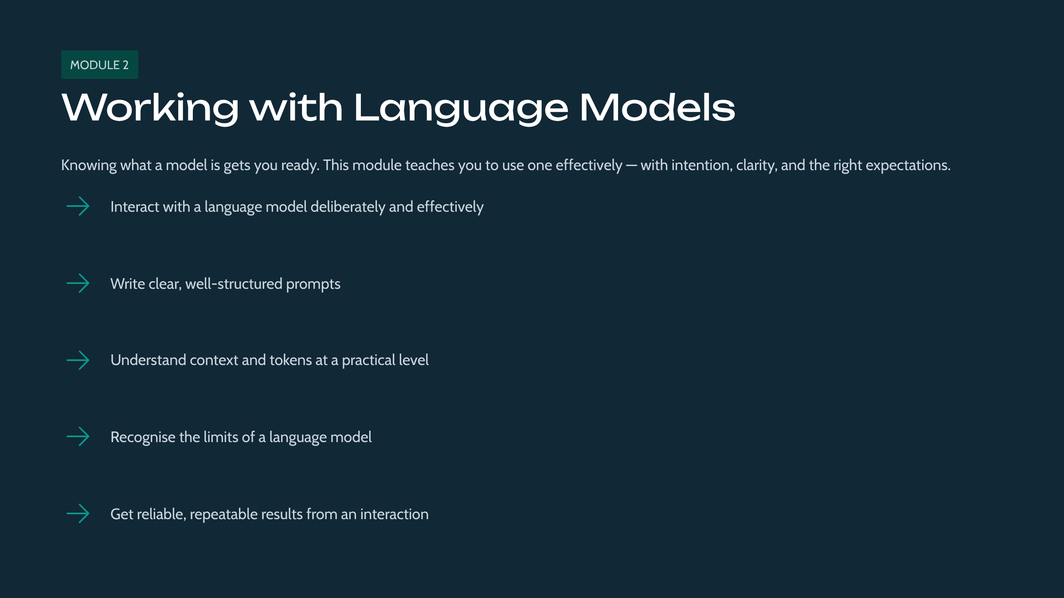

This module covers the practical basics of getting useful results from language models: prompting, context, and the shape of an interaction. You'll learn the everyday mechanics practitioners rely on, and leave able to interact deliberately rather than by trial and error.

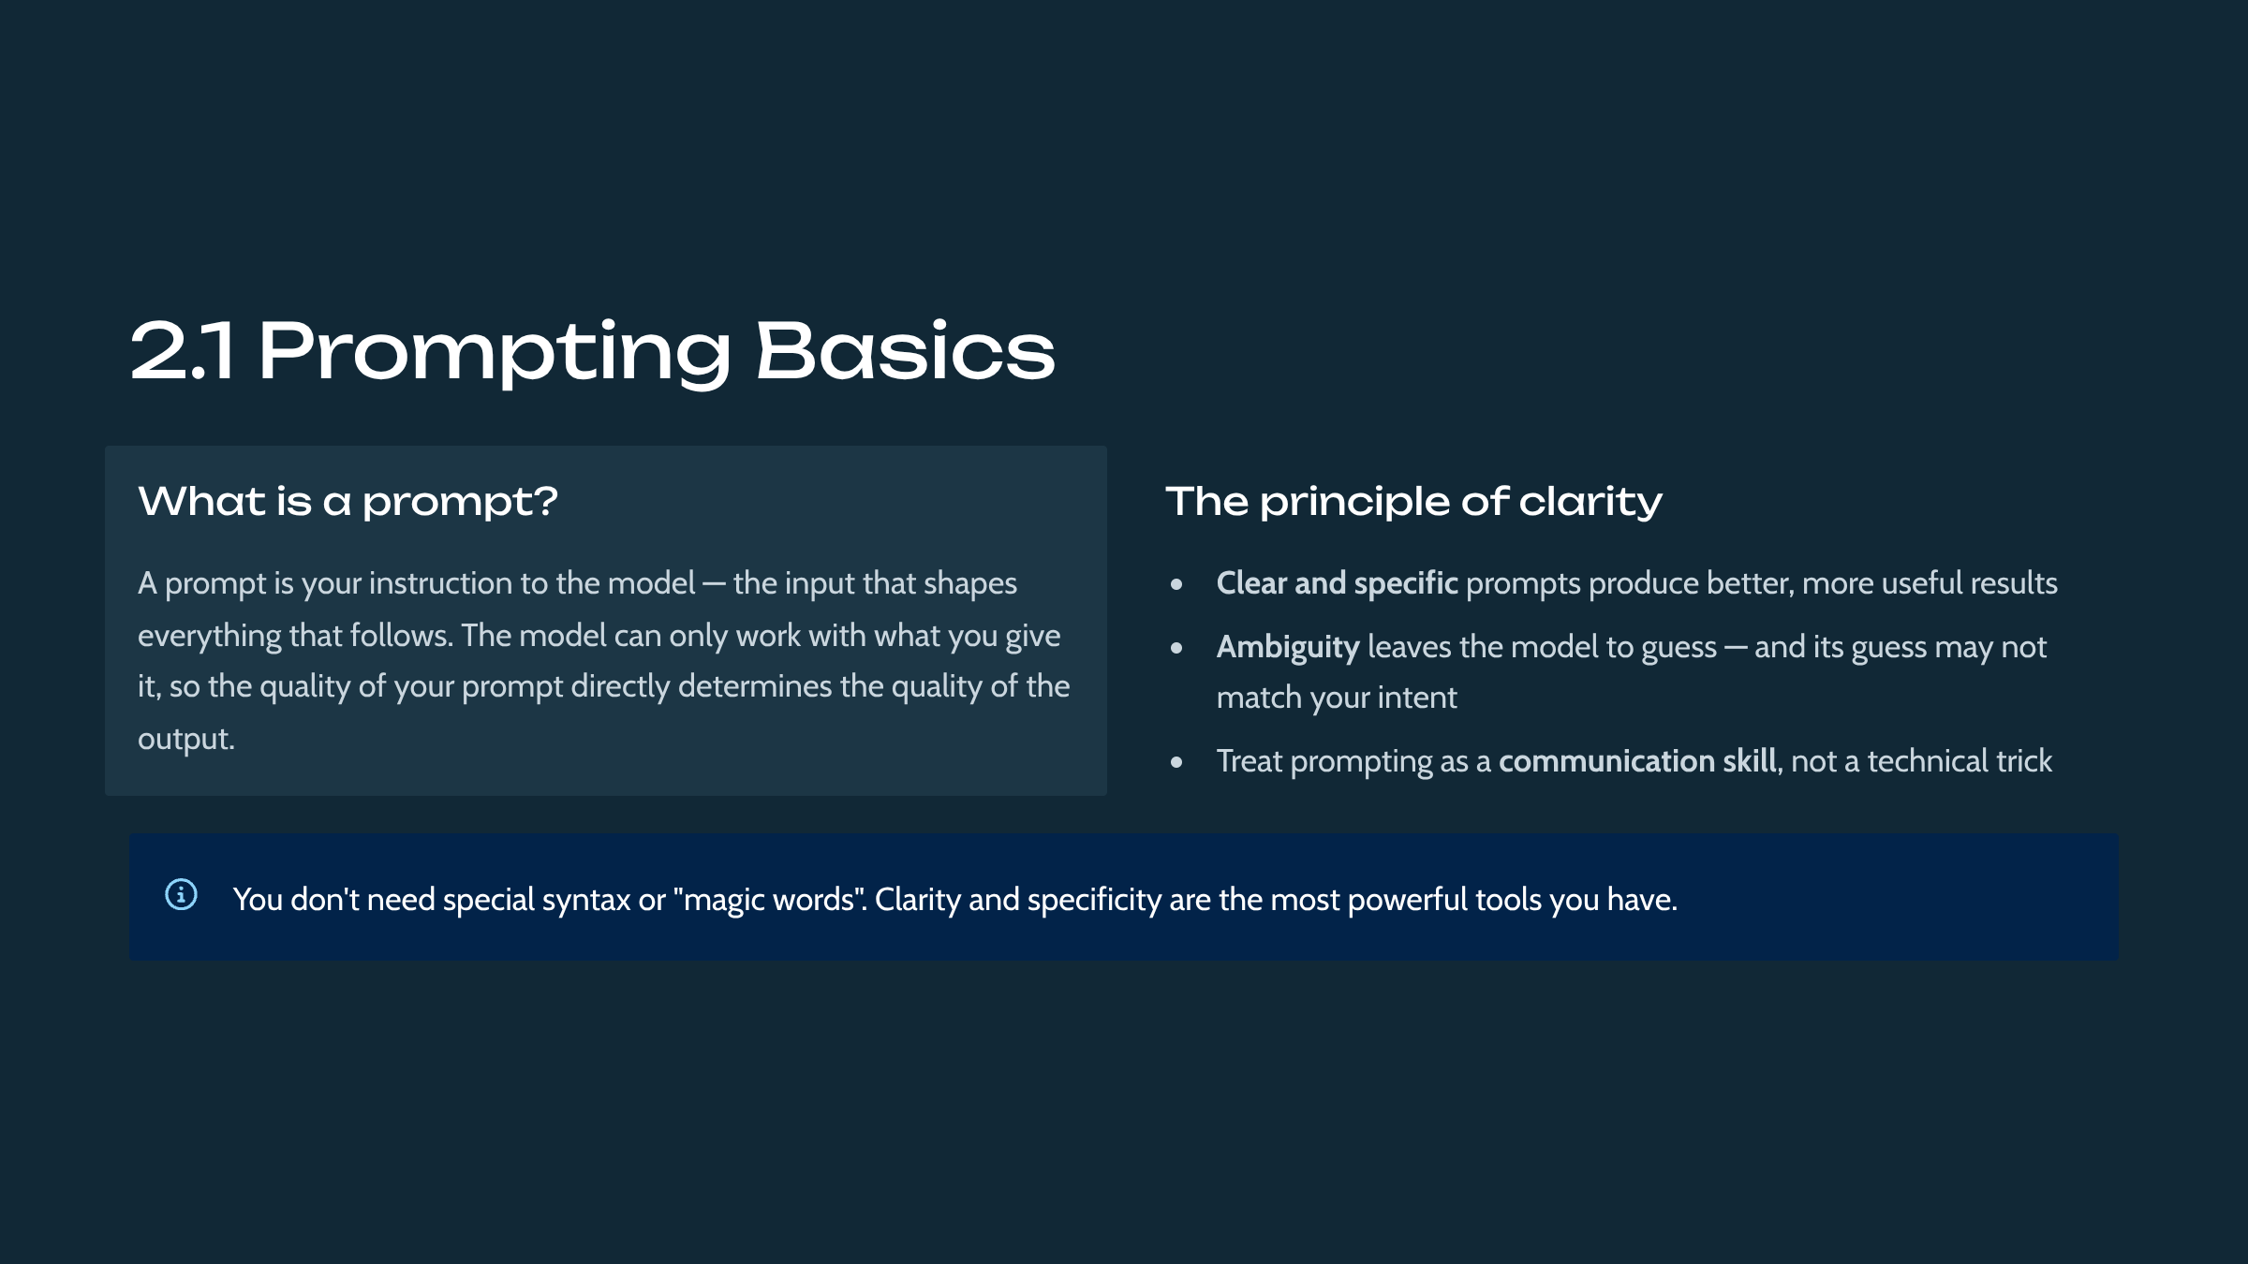

Prompting is the primary interface to a language model. The lesson establishes that prompt quality — clarity and specificity — is the dominant factor in output quality. This demystifies prompting: it is disciplined communication rather than secret phrasing, a theme developed in depth in the DEV-406 course.

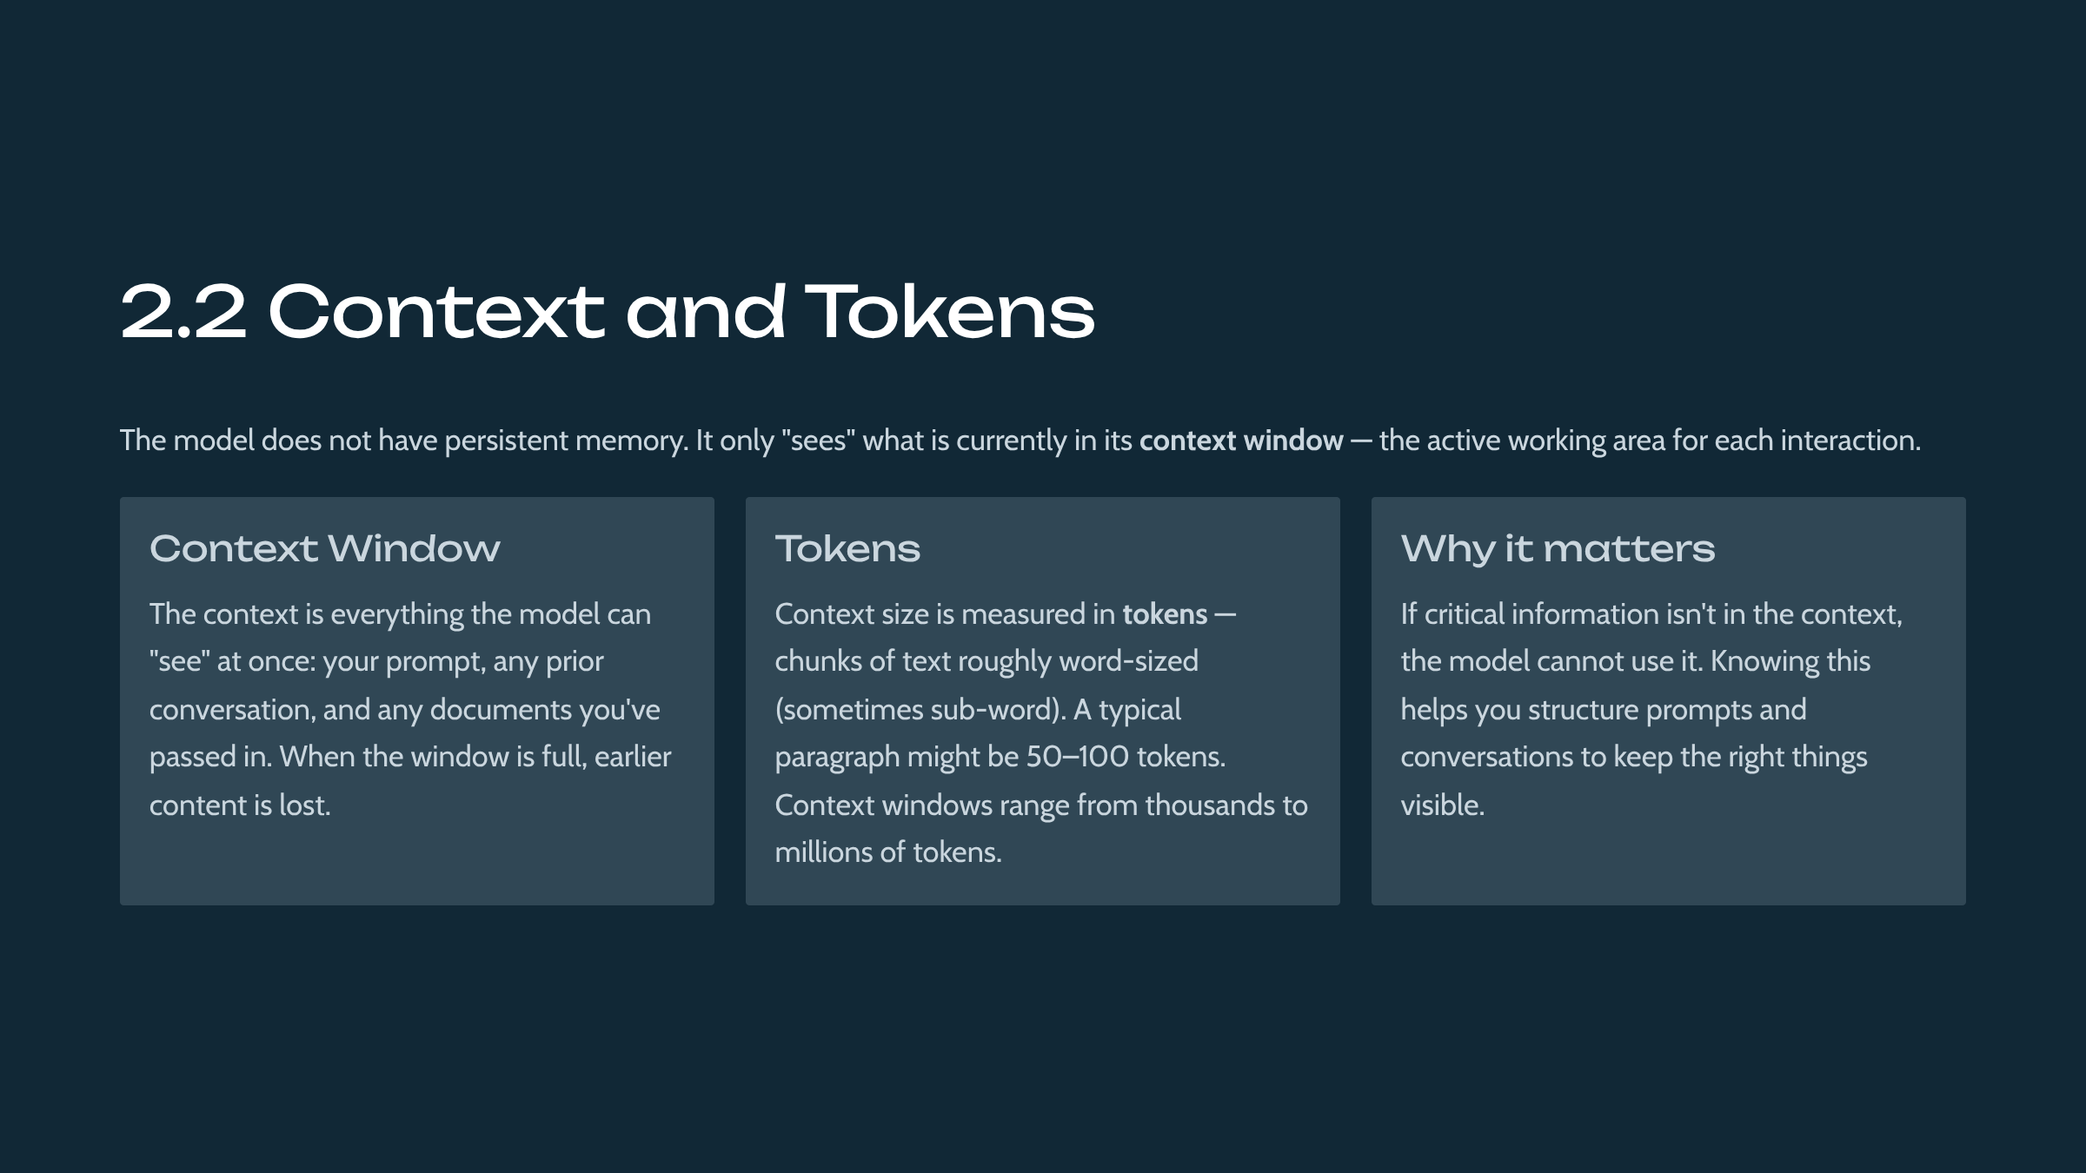

Context and tokens are foundational vocabulary. Context is the information available to the model at inference time; it is bounded, and that bound is measured in tokens, which are sub-word units of text. The key practical implication — the model only knows what is in its context — recurs throughout retrieval, memory, and agent topics in later courses.

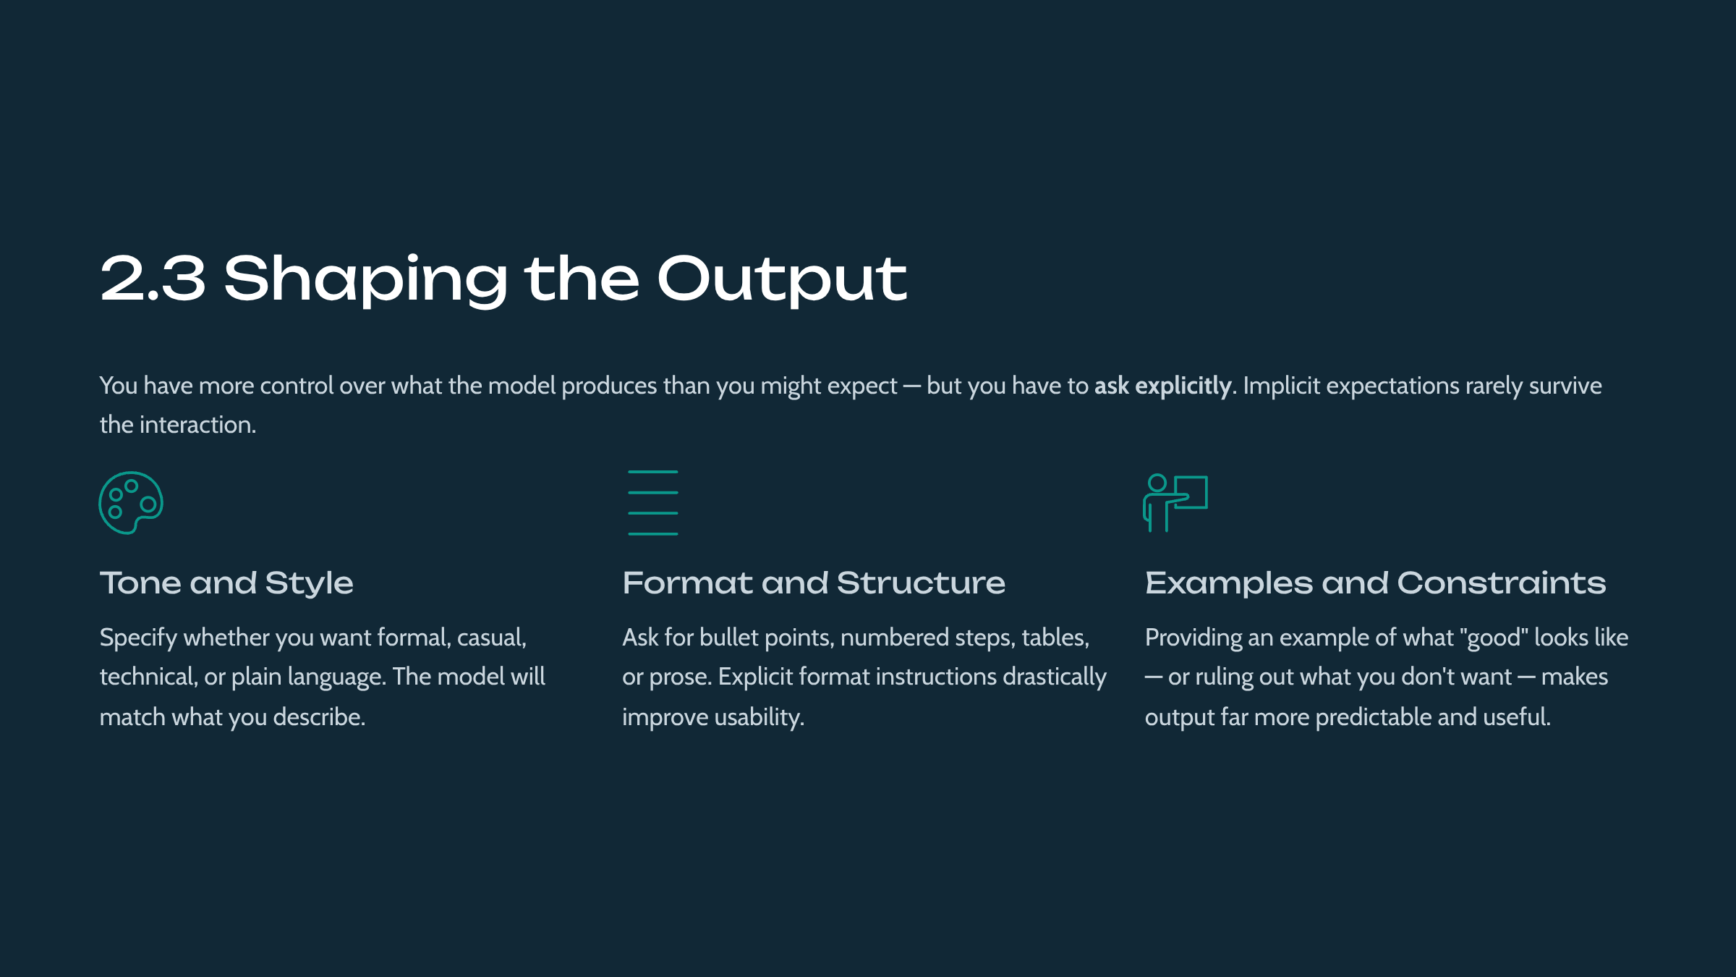

Output control is introduced at a basic level: students learn they can steer tone, format, and structure by asking explicitly and by providing examples or constraints. Predictable output is essential when model responses feed downstream systems, and this foreshadows the structured-output and system-prompt techniques in the developer track.



Understanding limits is as important as understanding capabilities. The lesson names three practical limits: hallucination, the absence of live knowledge, and the inability to reason over information not provided. Framing these as the tool's 'shape' encourages calibrated use rather than blind trust or dismissal.

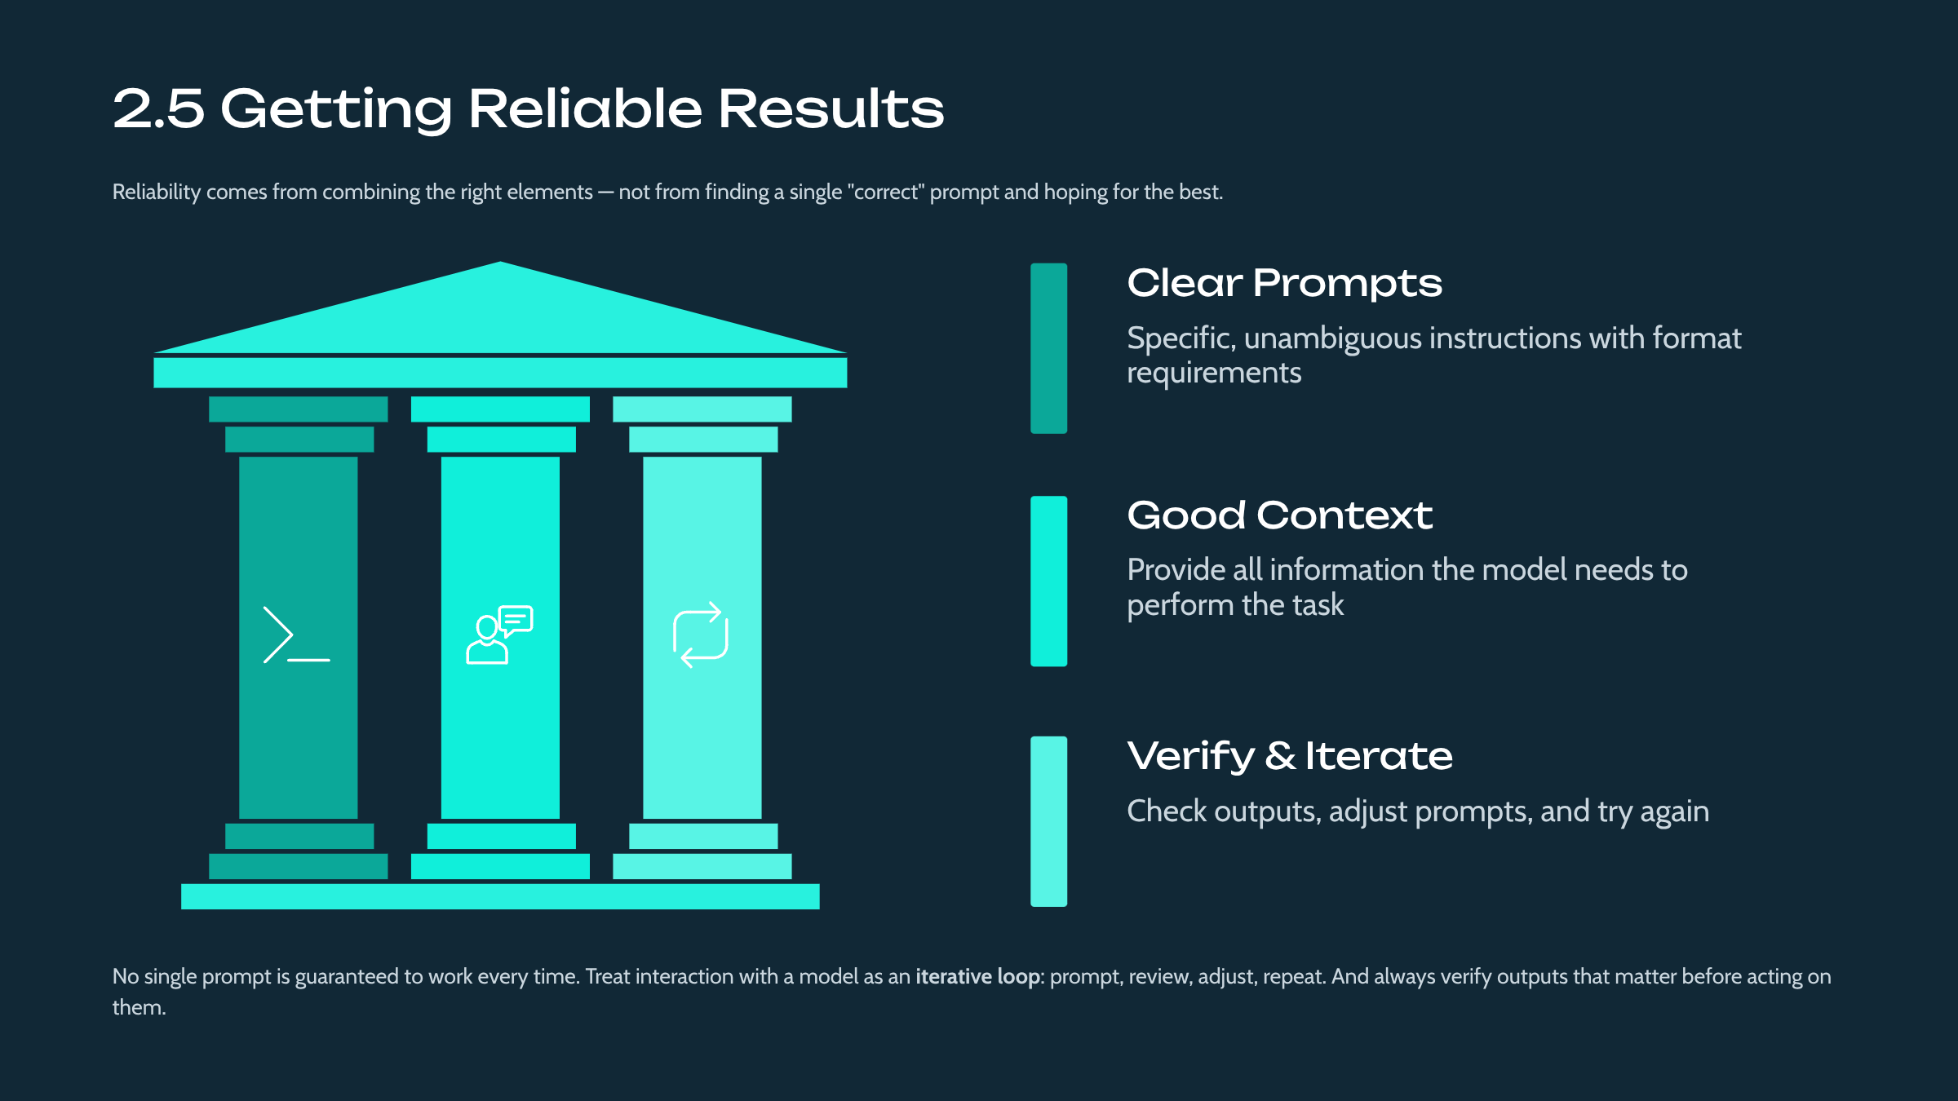

The module concludes by synthesizing the earlier lessons into a practical discipline for reliable results: clear prompts, appropriate context, explicit formatting, verification of important outputs, and iteration. This positions reliability as a repeatable practice rather than a matter of luck, setting expectations that carry into evaluation and product courses.

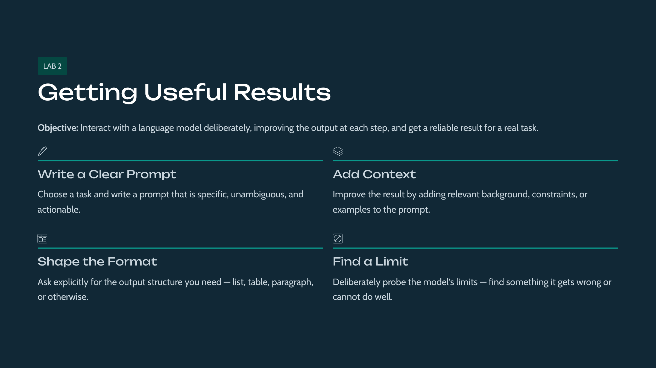

This lab gives students hands-on contact with the module's ideas. Students practice prompting and shaping a language model's output through guided tasks. The detailed procedure is in the accompanying Lab Manual.

Module 3: The AI Application Landscape


This module maps the kinds of AI applications you'll encounter and build, from assistants to retrieval systems to agents. You'll leave able to recognize the main application patterns and where each fits — giving later, deeper courses somewhere to hang.

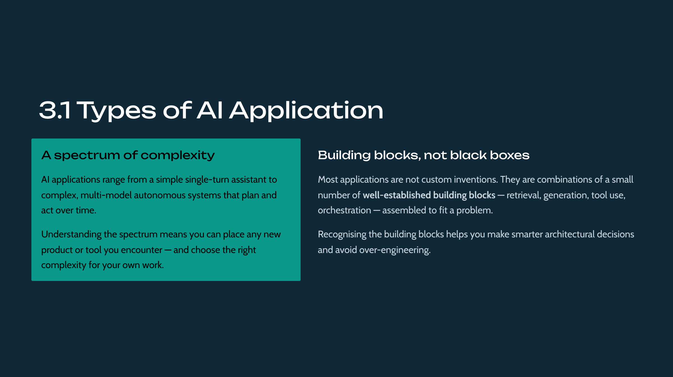

The landscape of AI applications can seem overwhelming to newcomers. This lesson reframes it: most applications are combinations of a small number of building blocks. Learning to recognize these blocks gives students a durable way to categorize any application they encounter, rather than treating each as novel.

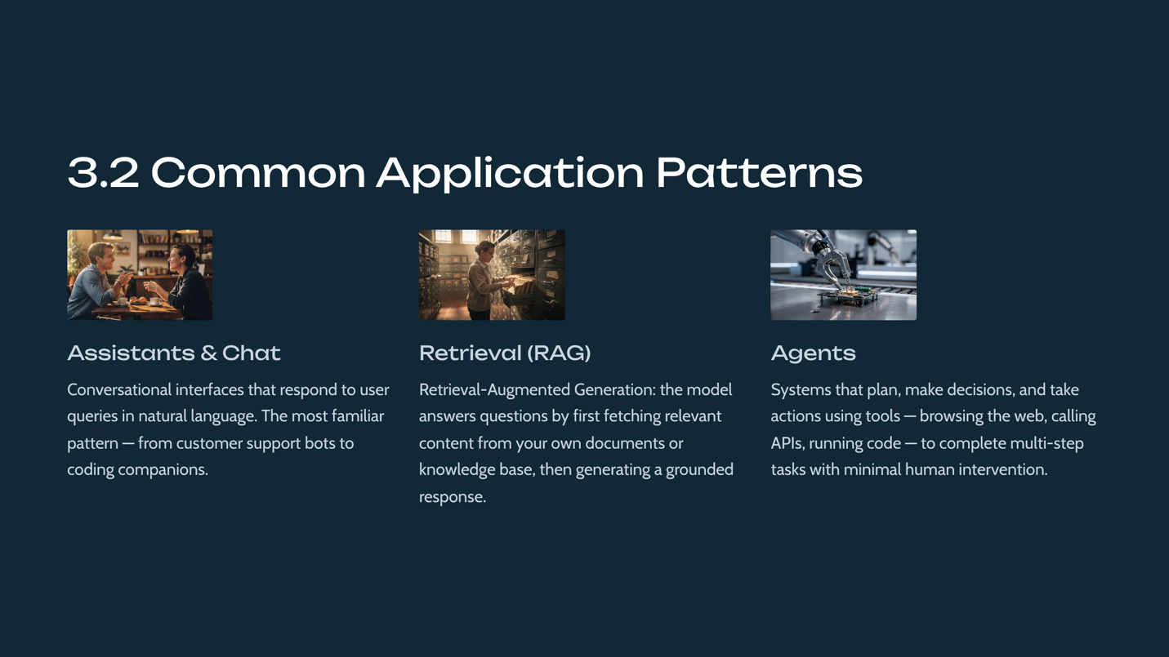

Three patterns cover the majority of applications: conversational assistants, retrieval-augmented generation (RAG) that grounds answers in provided content, and agents that plan and act. Naming these patterns gives students a shared vocabulary and directly previews entire courses in the developer track (for example, DEV-403 on RAG and DEV-414 on agents).

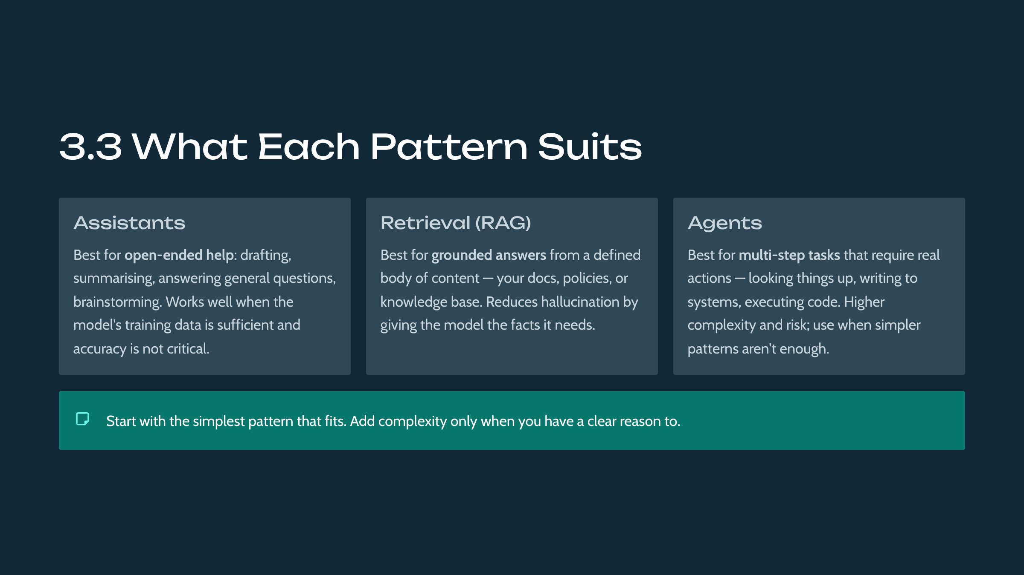

Beyond naming patterns, students learn what each is best suited for: assistants for open-ended generation, retrieval for grounded and source-bound answers, and agents for multi-step, tool-using tasks. This fit-to-purpose judgment prevents a common mistake — forcing a problem onto the wrong pattern — and is developed further throughout the developer and product tracks.

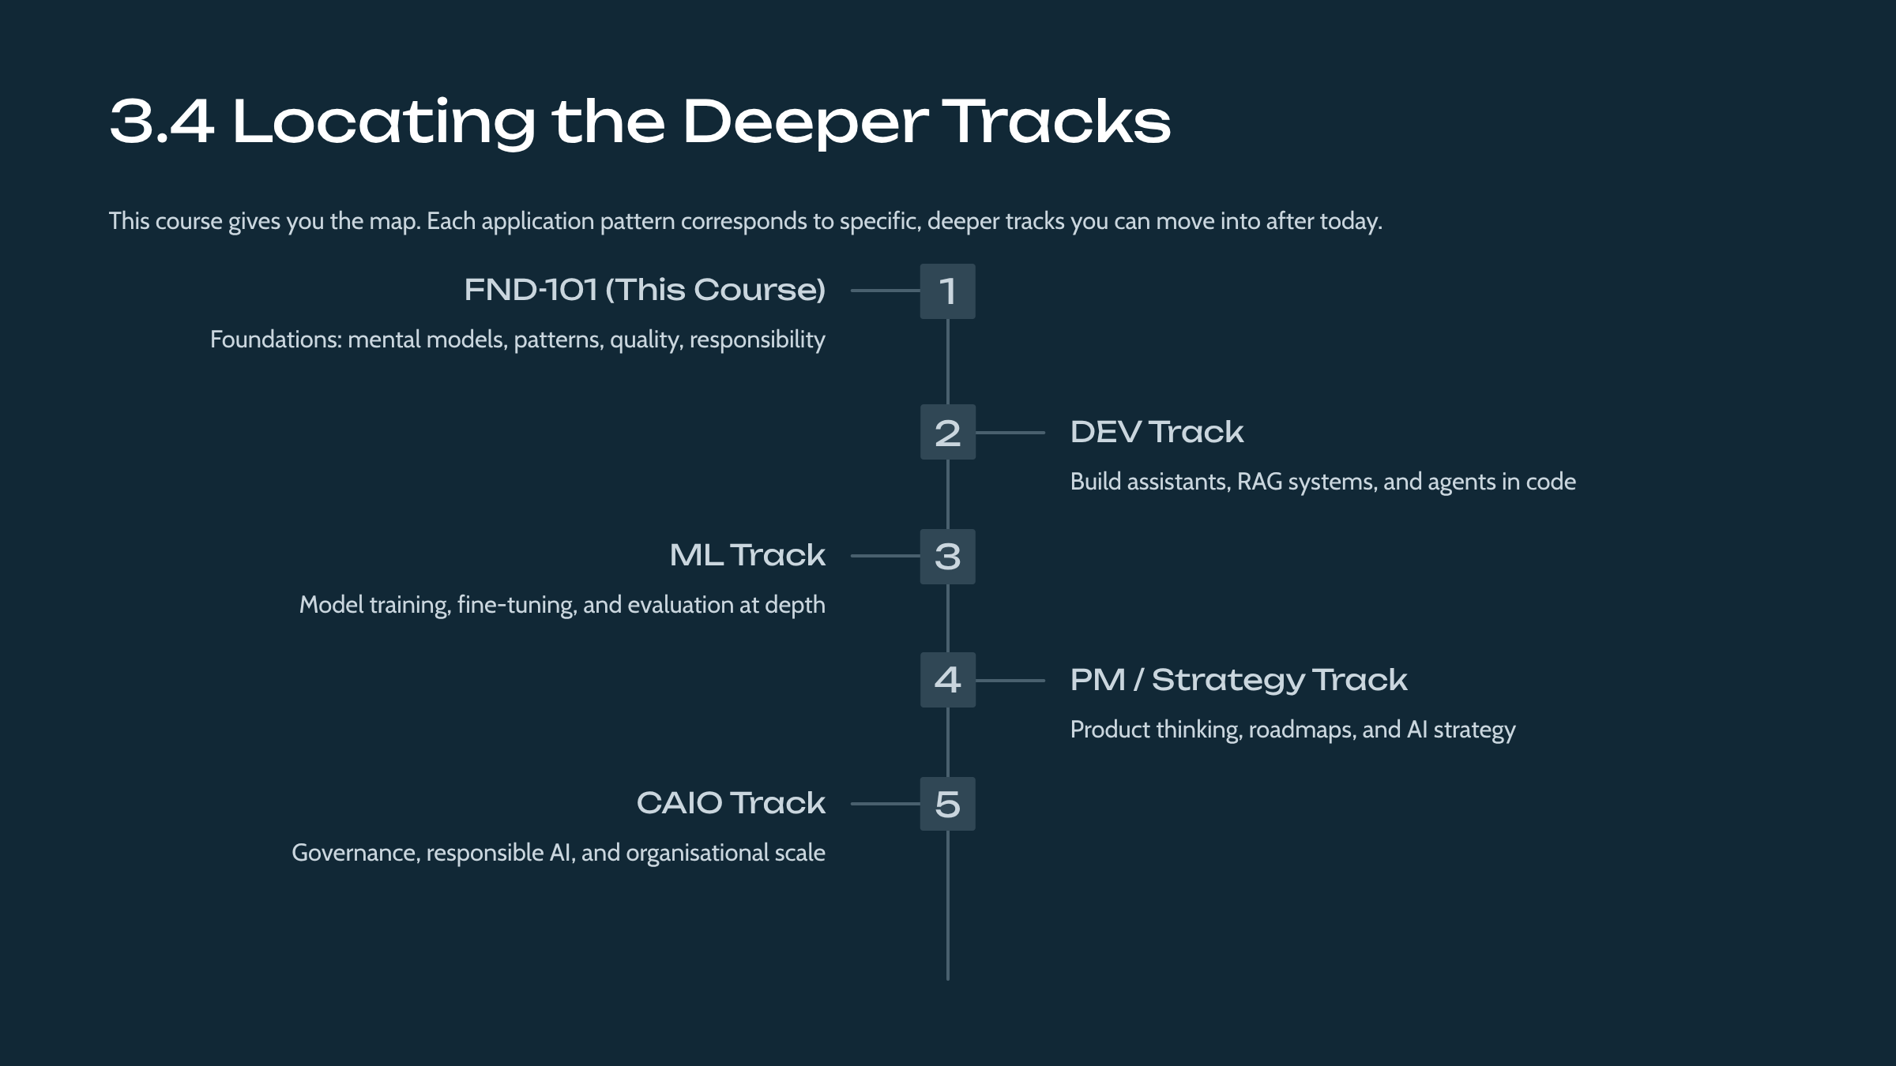

The application landscape doubles as a navigation aid for the catalogue. Each pattern points to the courses that address it in depth, and the five specialist tracks are located relative to the landscape. This helps students choose their next course intentionally after completing the foundations.

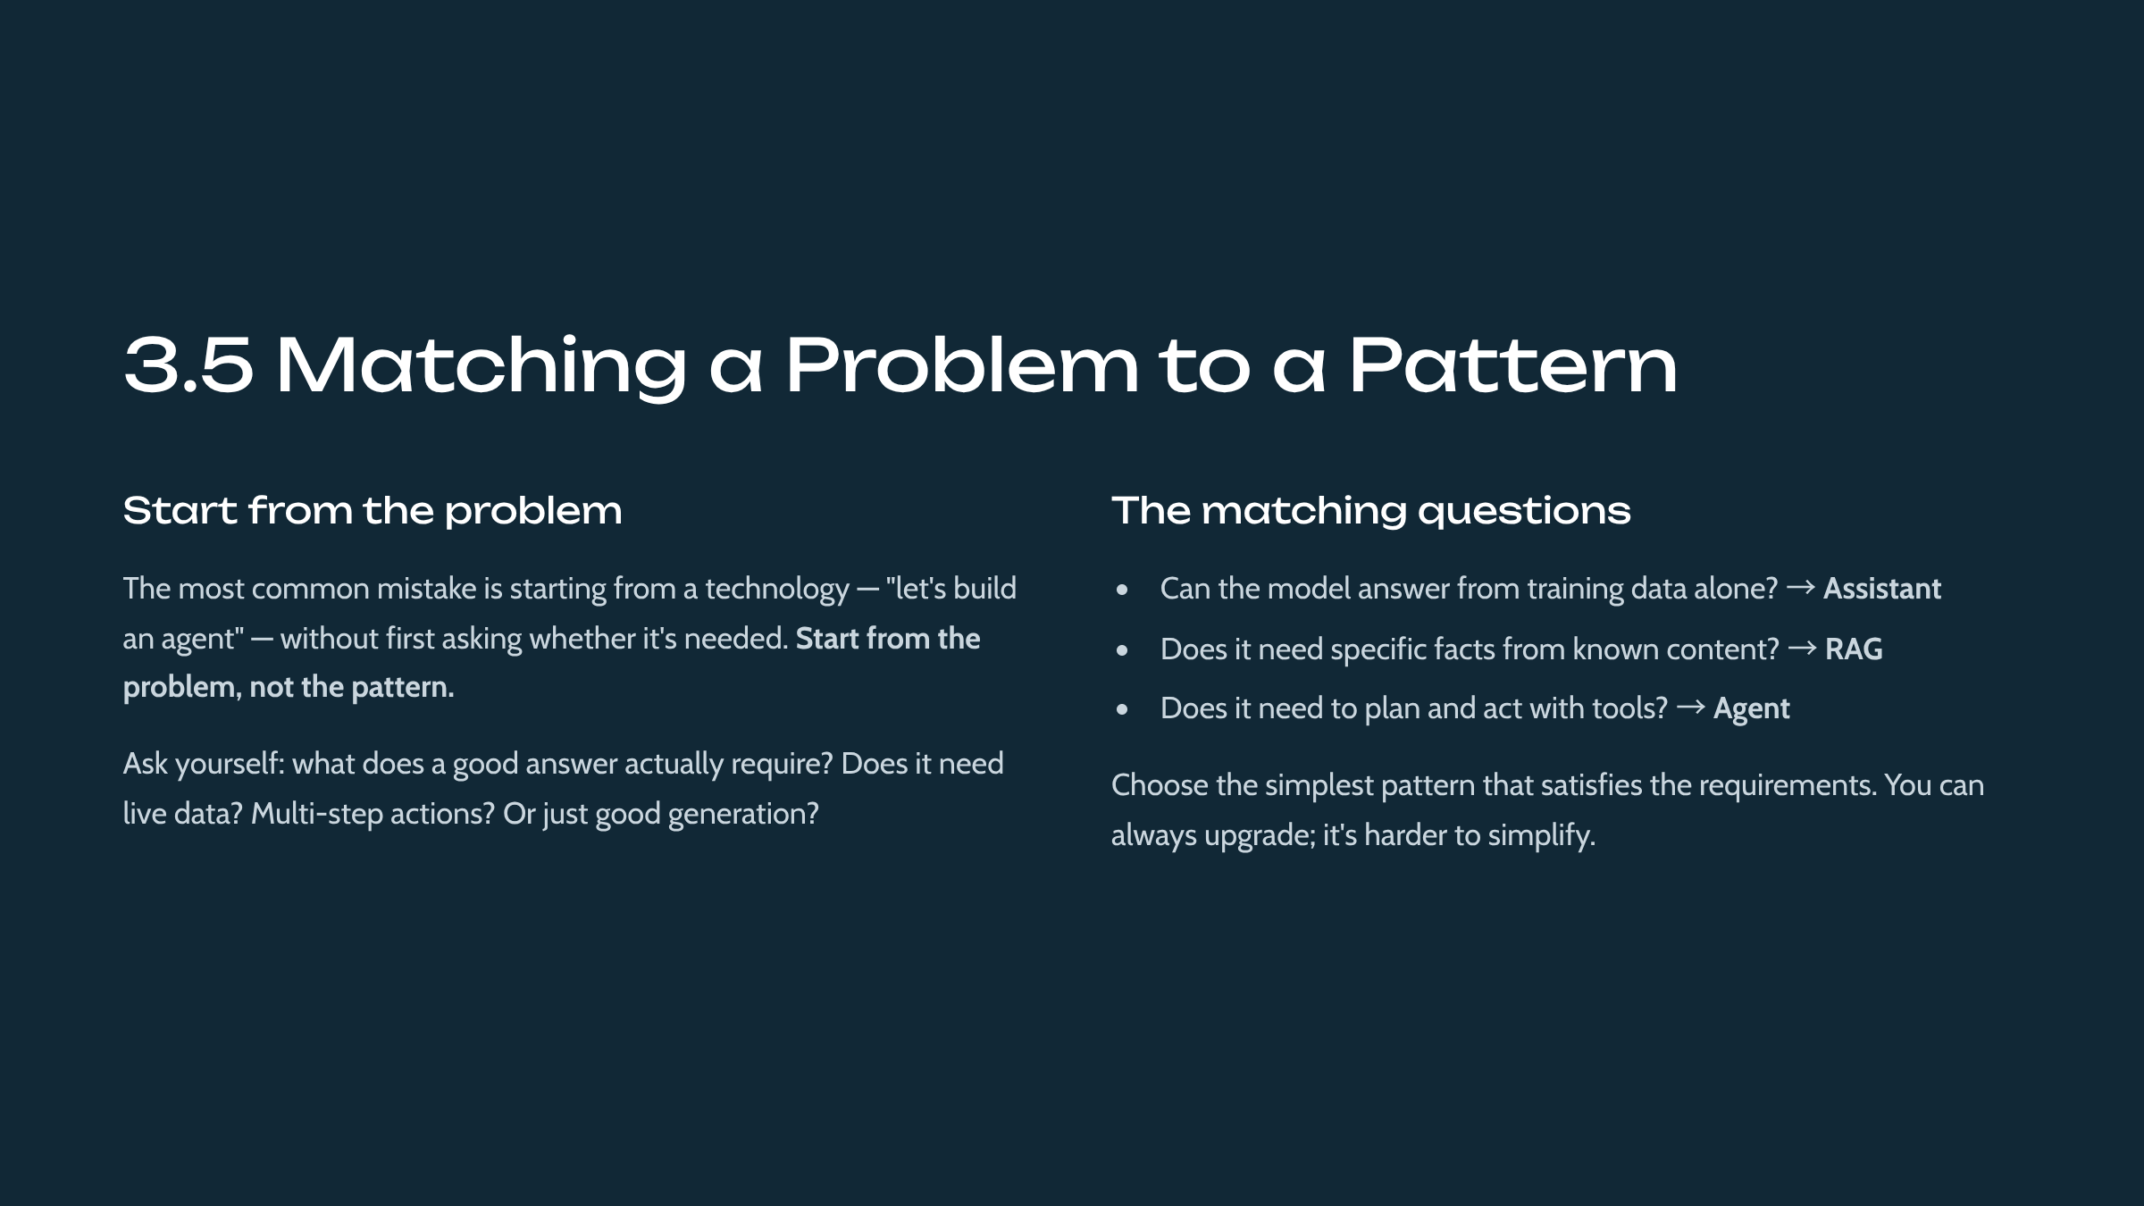

The module concludes with a decision skill: match the problem to the simplest sufficient pattern, reasoning from the requirement rather than the technology. Emphasizing simplicity guards against over-engineering, a recurring risk in AI projects and a theme echoed in the architecture and product tracks.

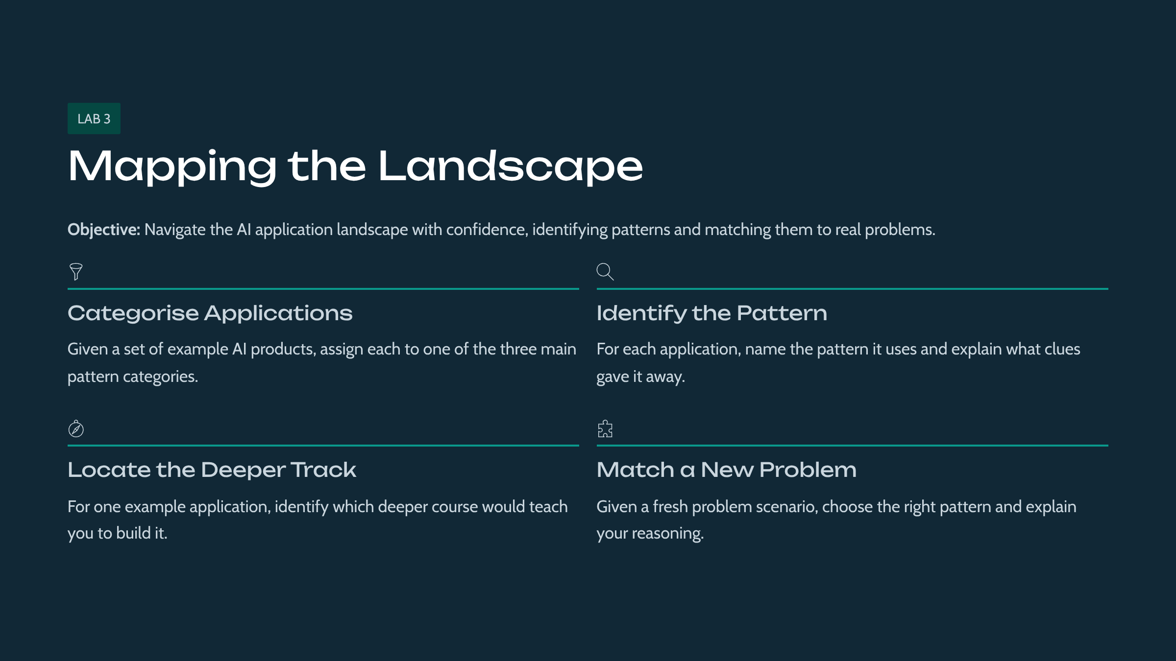

This lab gives students hands-on contact with the module's ideas. Students map a set of example applications onto the landscape and match problems to patterns. The detailed procedure is in the accompanying Lab Manual.

Module 4: Data, Evaluation, and Quality Basics
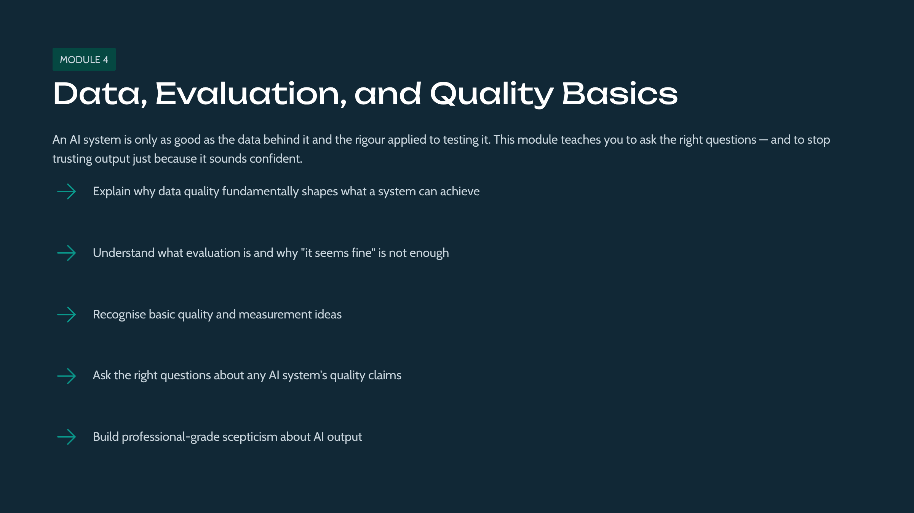

This module introduces data quality, evaluation, and measuring whether an AI system works — ideas that recur throughout every track. You'll learn why these matter and the basic vocabulary, and leave able to ask the right questions before building.

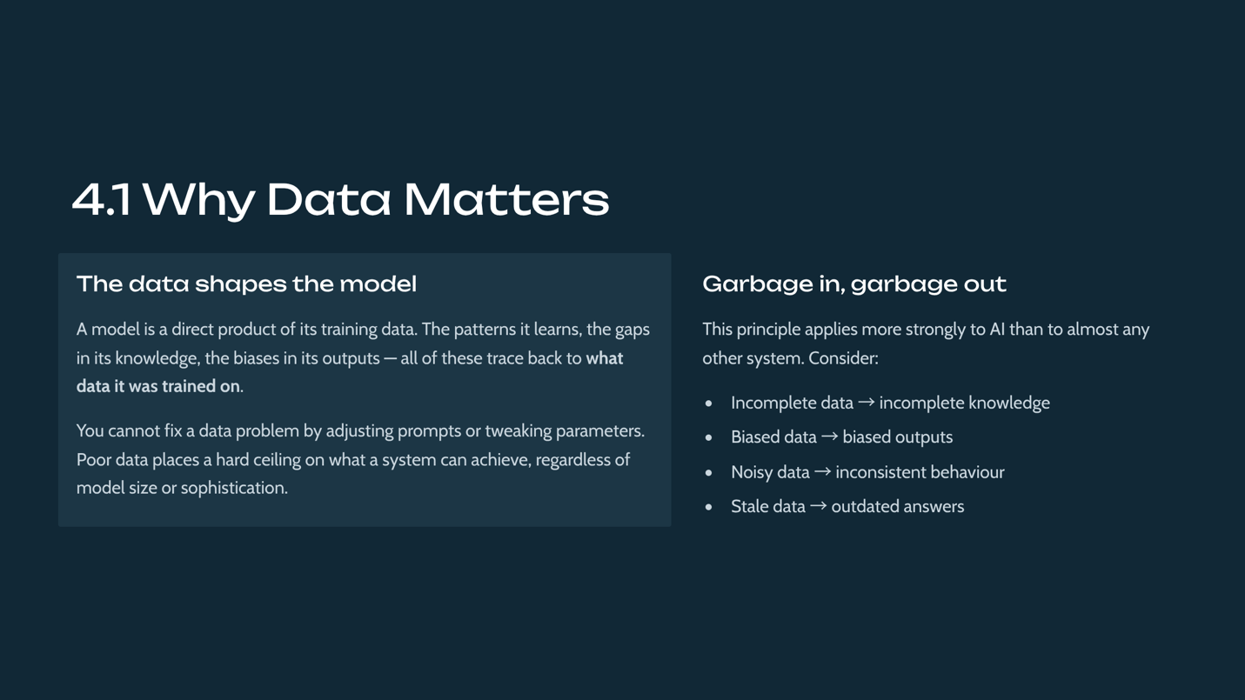

Data quality is foundational because models inherit the characteristics of their training data. Poor data imposes a hard ceiling on system quality, and its flaws — bias, gaps, errors — are reproduced by the model, often without obvious symptoms. Recognizing that many apparent model problems are really data problems is a mature insight the course plants early.

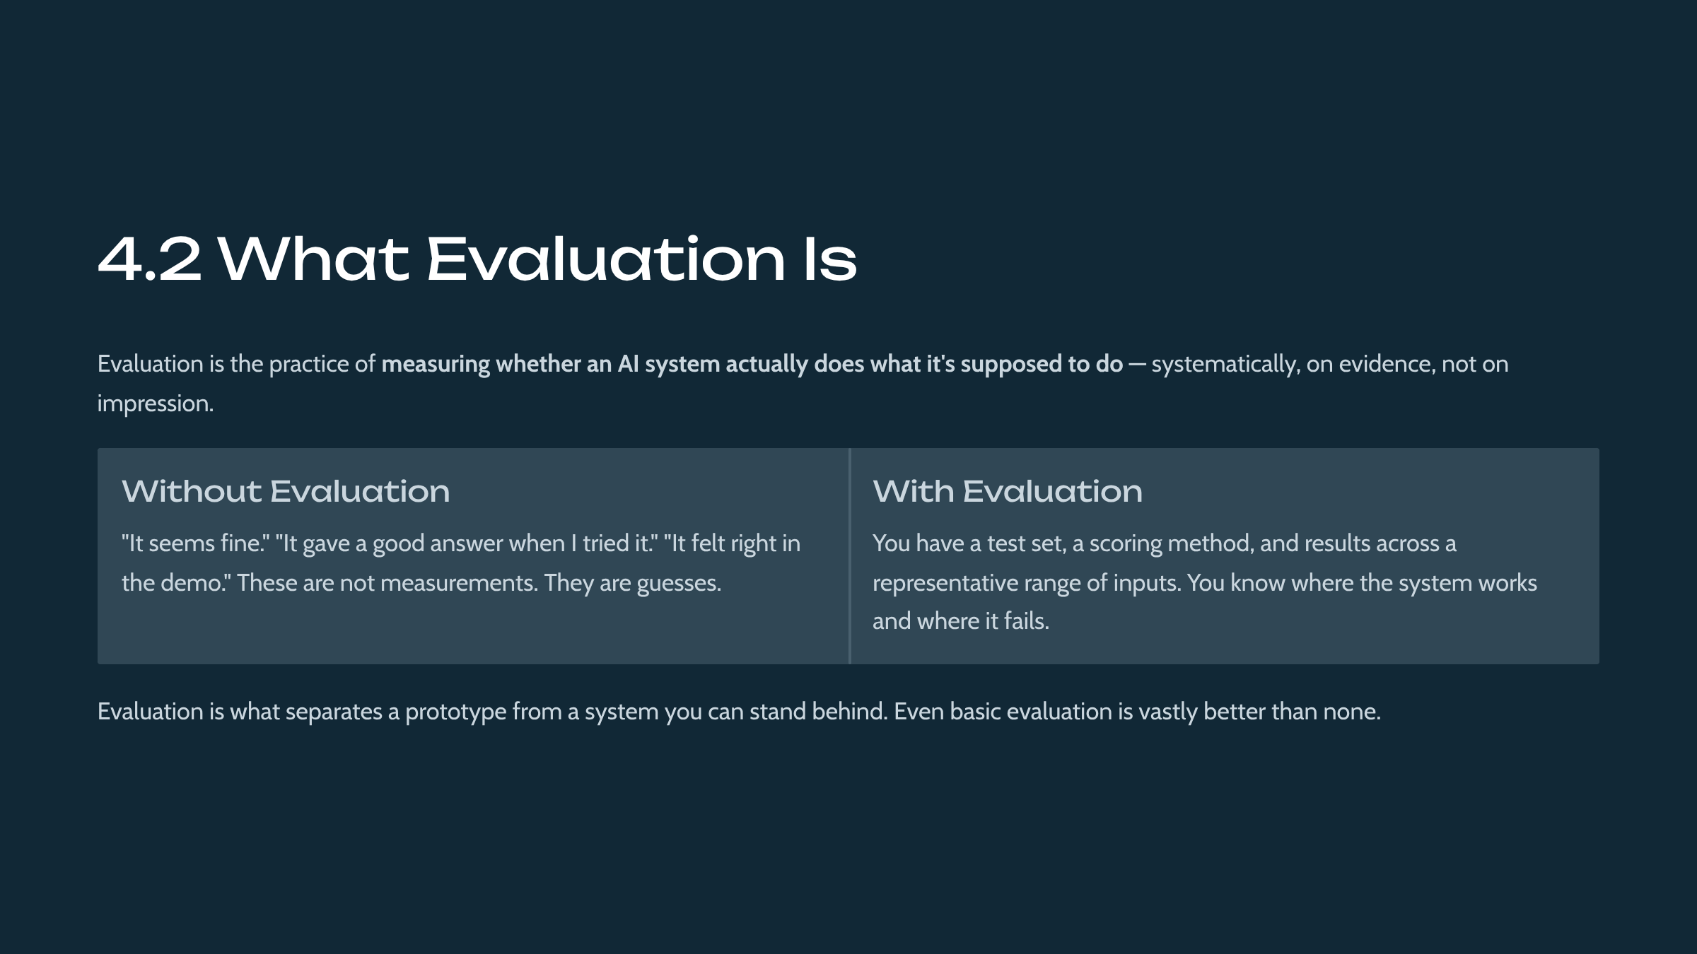

Evaluation is defined as the systematic measurement of whether a system performs its task, based on evidence rather than impression. The probabilistic nature of AI makes evaluation both harder and more essential than in conventional software. This lesson establishes evaluation as a first-class concern, expanded greatly in MLE-456 and the measurement courses.

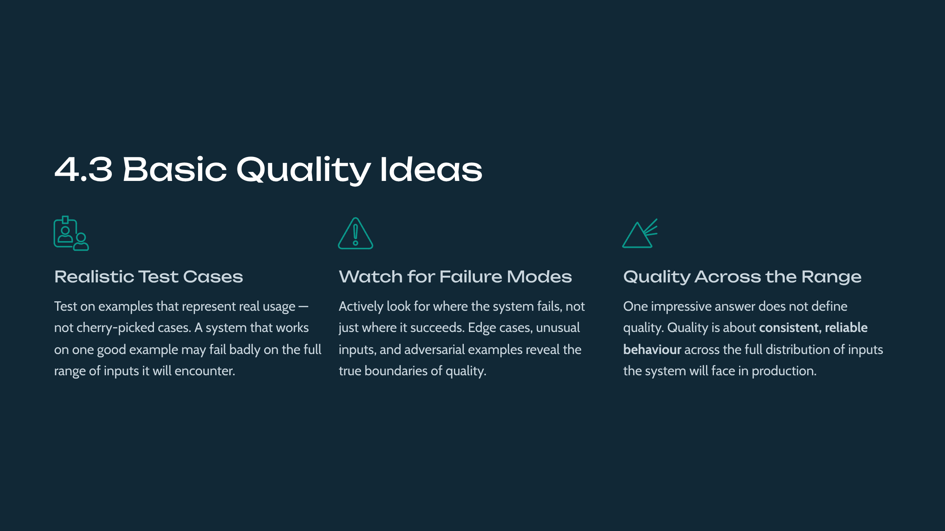

Students learn a handful of durable quality principles: use realistic and representative test cases, attend to failures rather than only successes, and judge quality across the full input distribution rather than by isolated impressive outputs. These principles counter the 'demo trap,' where a system looks good on curated examples but fails in real use.

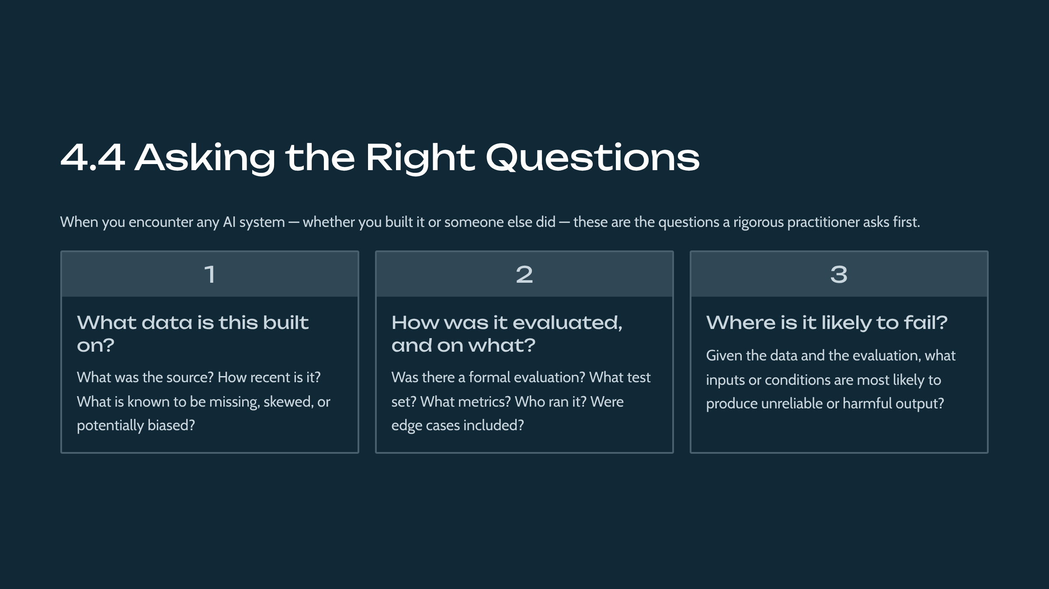

This lesson equips students with three high-leverage questions — about data provenance, evaluation, and likely failure modes — that quickly surface the quality of any AI system. Crucially, the absence of good answers is itself diagnostic, teaching students to treat unexamined systems with appropriate caution.

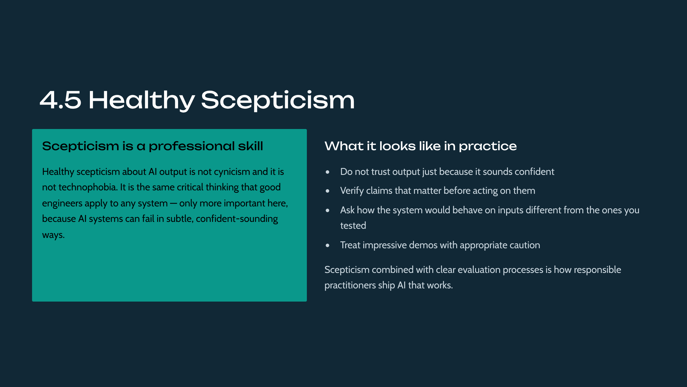

The module closes by consolidating its lessons into a disposition of healthy skepticism: not trusting fluent output uncritically, and verifying what matters. The course frames this as professional rigor rather than cynicism, distinguishing it from a reflexive distrust of AI and positioning it as a transferable engineering value.

This lab gives students hands-on contact with the module's ideas. Students examine an example AI system and ask the right questions about its data and quality. The detailed procedure is in the accompanying Lab Manual.

Module 5: Building Responsibly and Safely
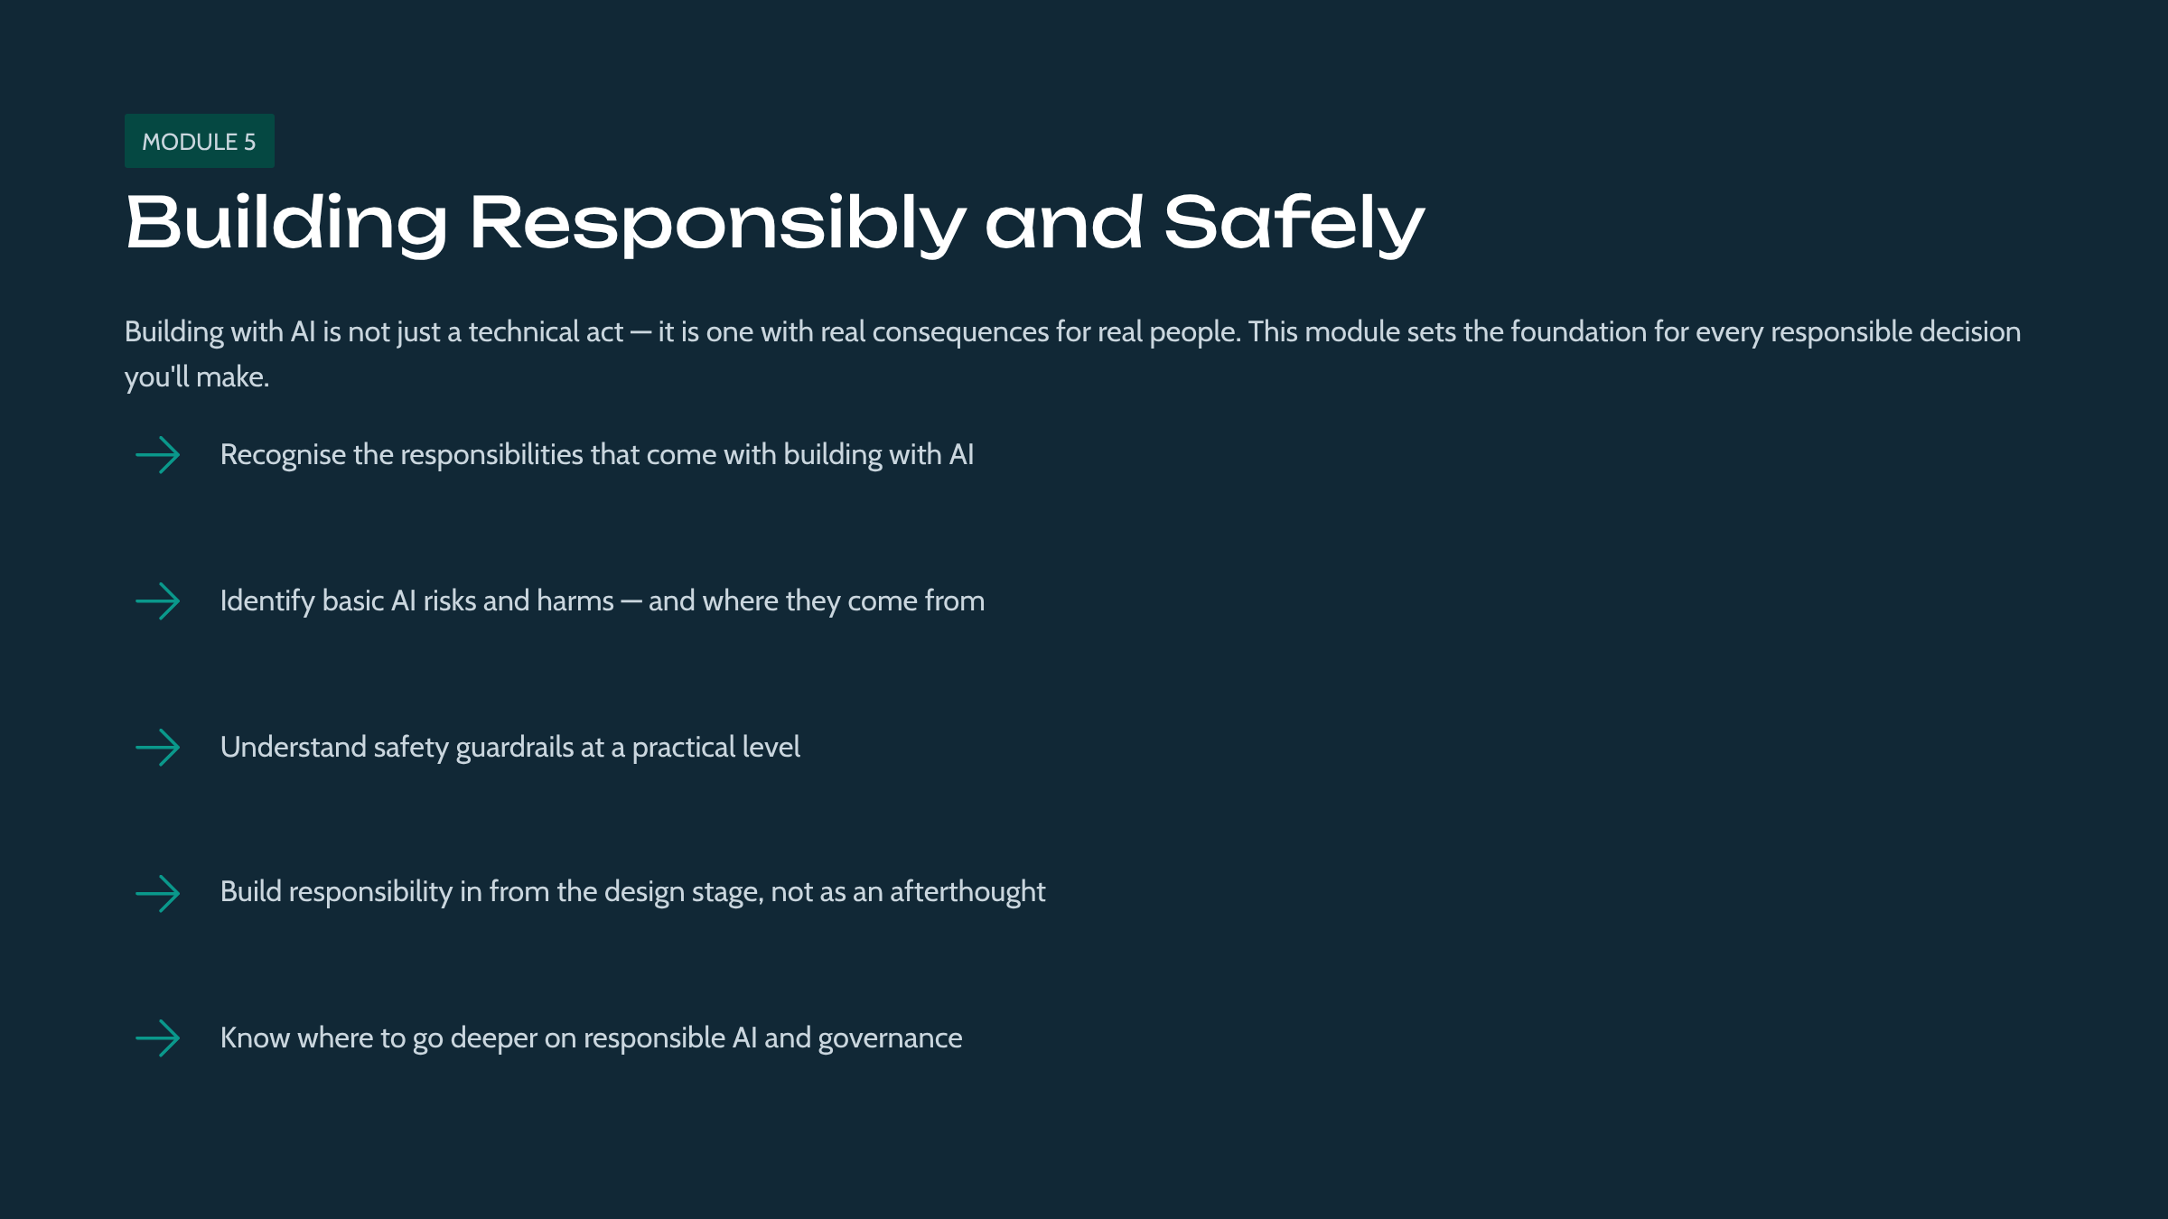

This final module introduces responsibility and safety as things you build in from the start, not add later. You'll learn the basic obligations and risks that apply to any AI work, and where to go deeper.

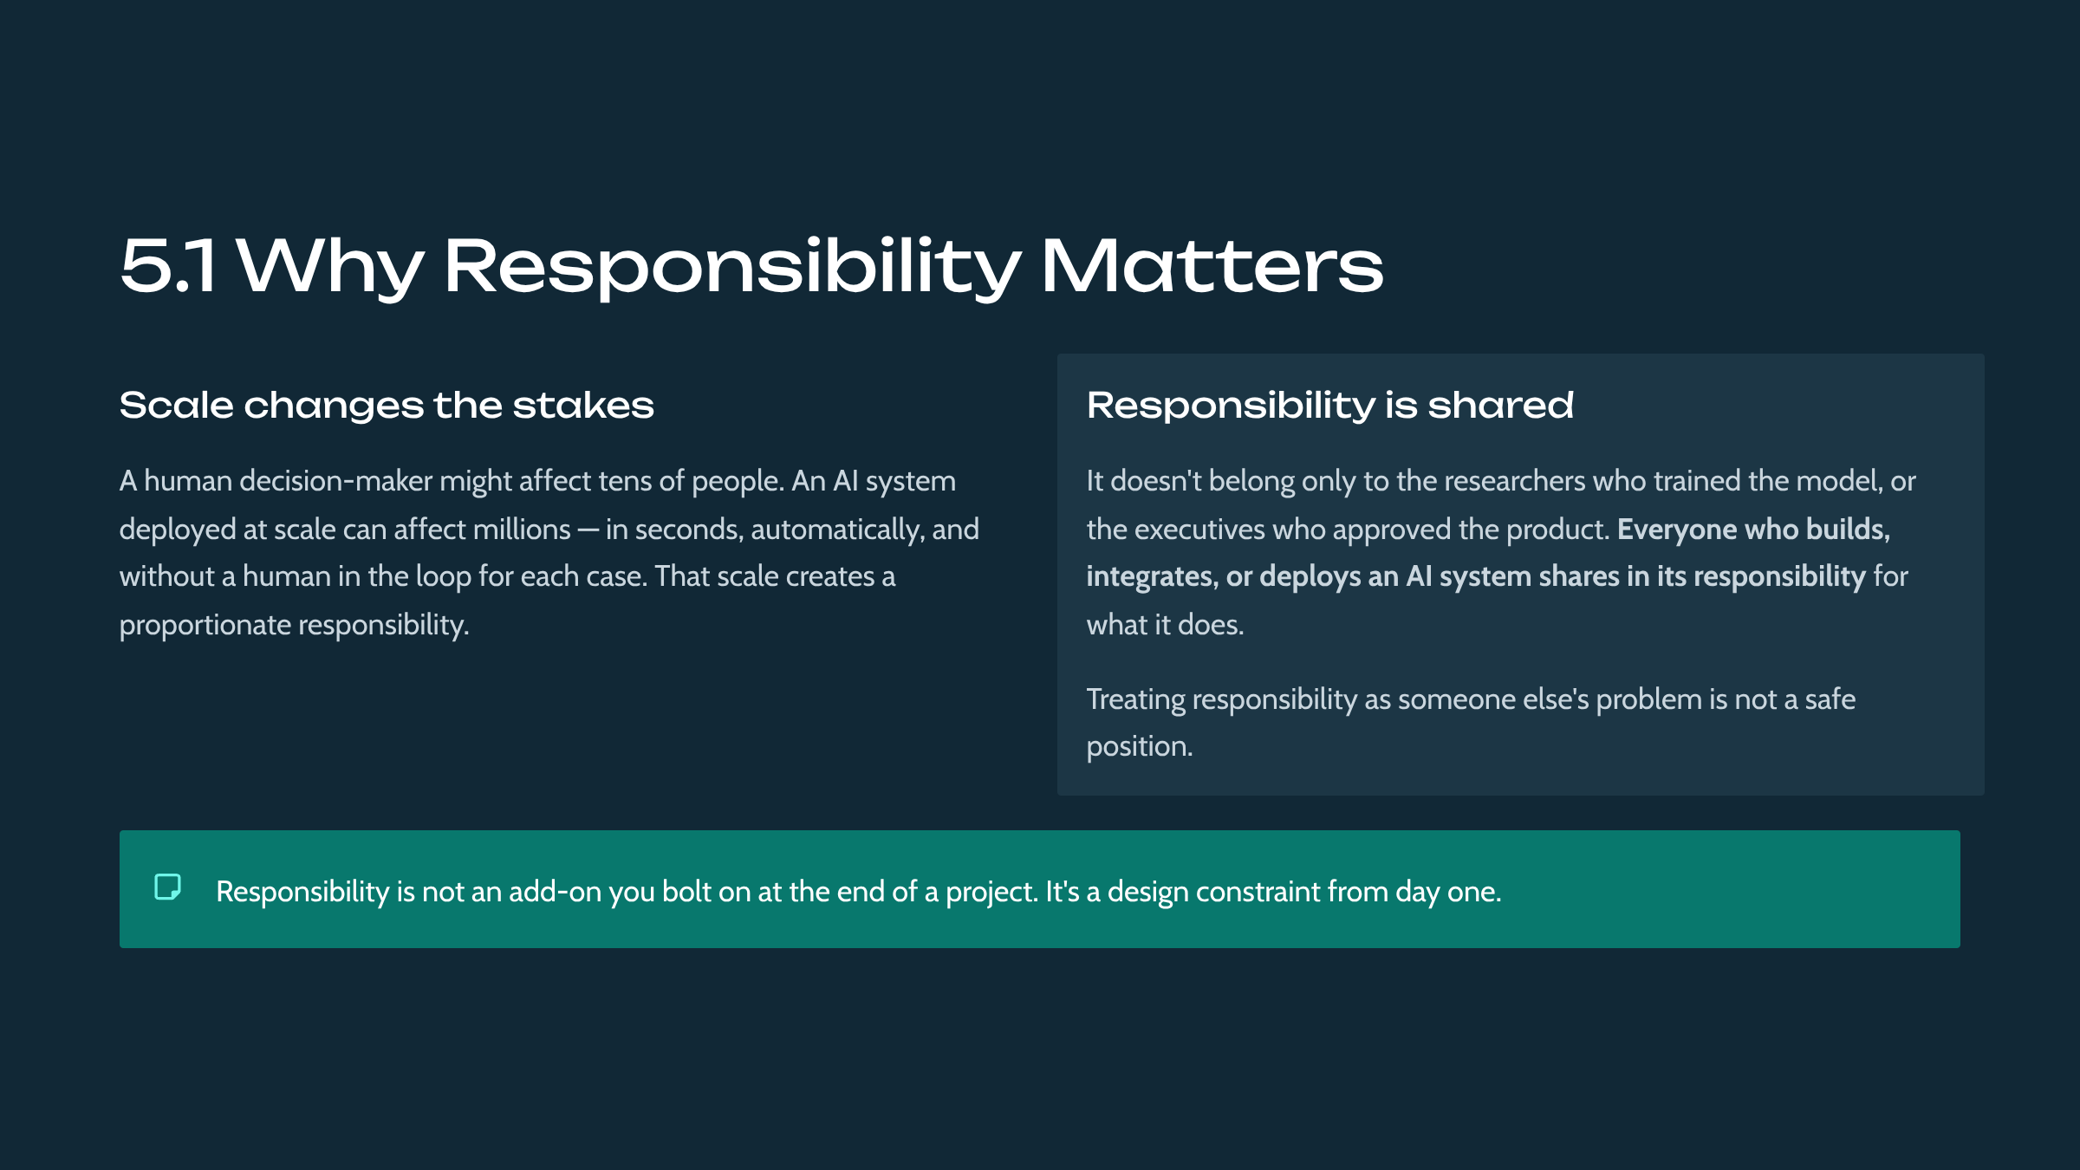

Responsibility is presented as intrinsic to building with AI rather than a separate compliance step. Because AI can affect people at scale and often invisibly, the course establishes that responsibility is shared by everyone who builds, not delegated to specialists. Placing this module last frames it as the lens through which all prior material should be applied.

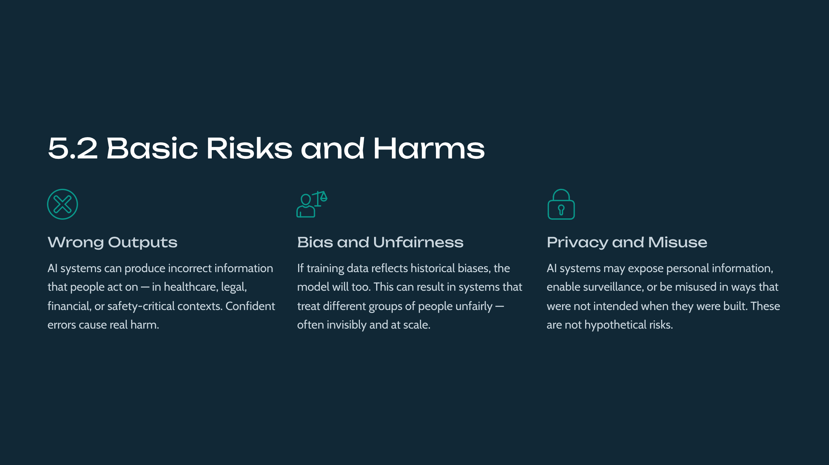

The lesson surveys the principal categories of AI risk at an introductory level: harmful erroneous outputs, unfair bias, privacy concerns, and misuse. The goal is recognition and seriousness rather than expertise; deeper treatment lives in the responsibility, governance, and risk courses across the tracks.

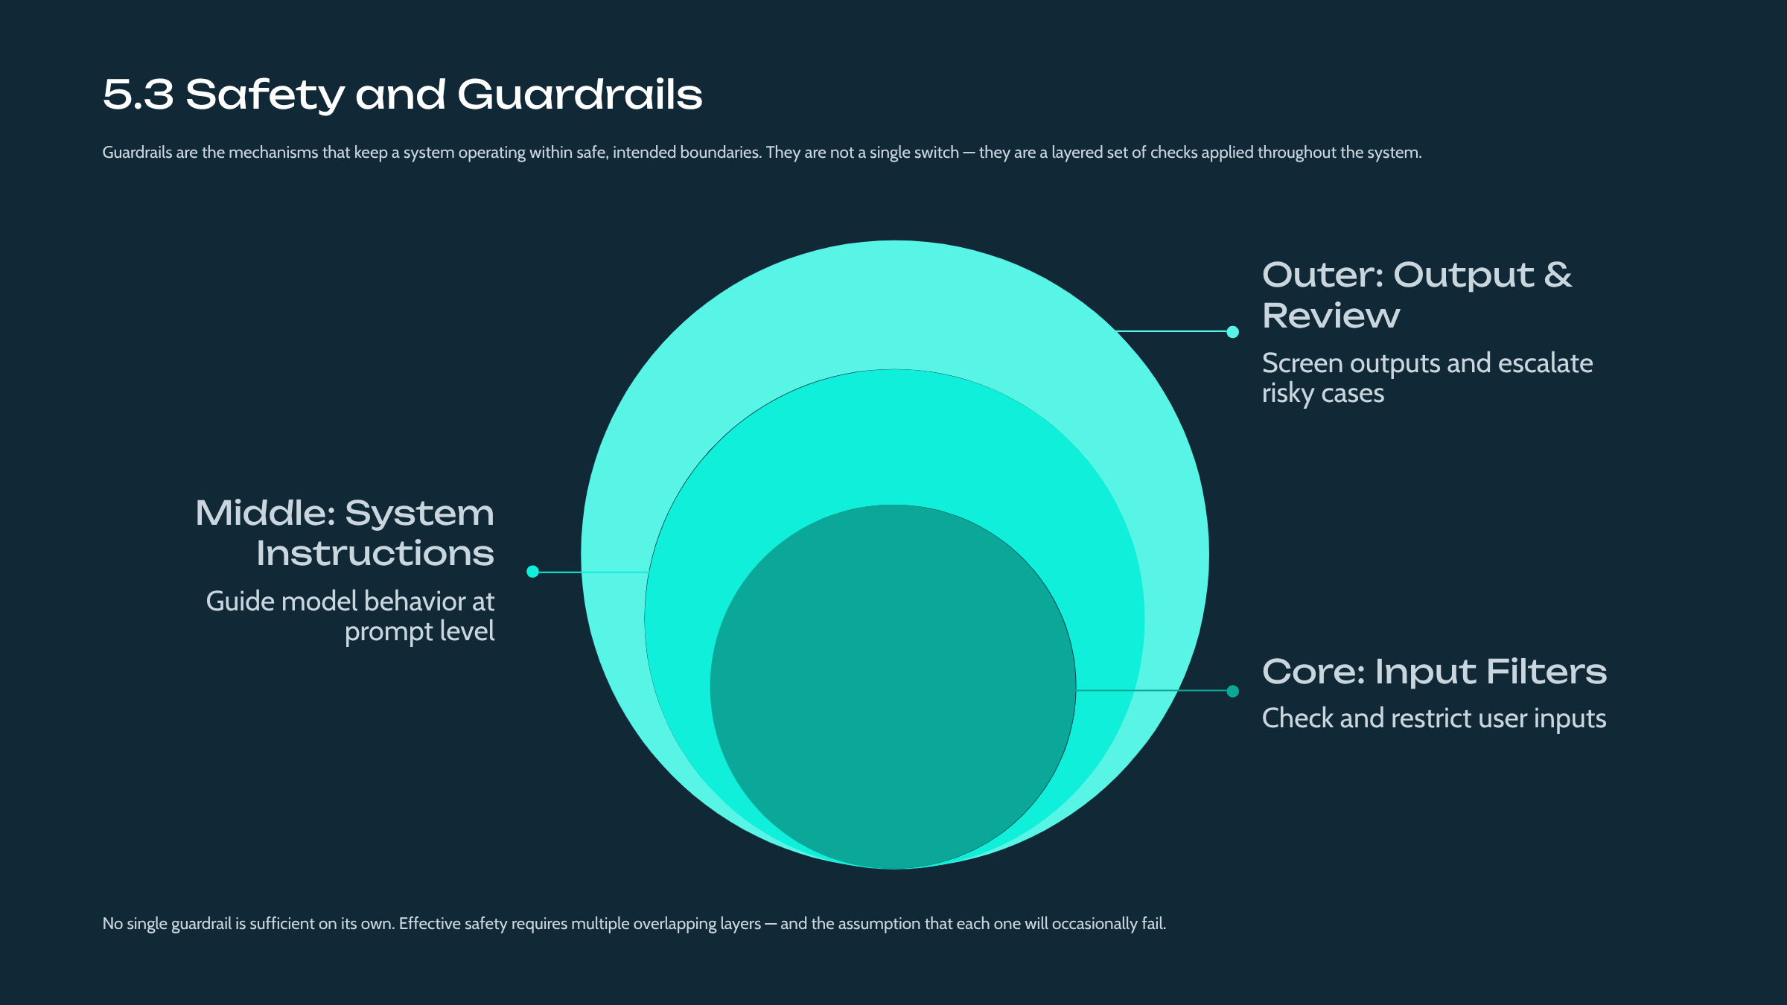

Guardrails are introduced conceptually as controls that keep a system within acceptable bounds by checking inputs and outputs. The key foundational point is that safety is layered — no single control suffices — which prepares students for the detailed guardrails and safety engineering in DEV-410 and related courses.

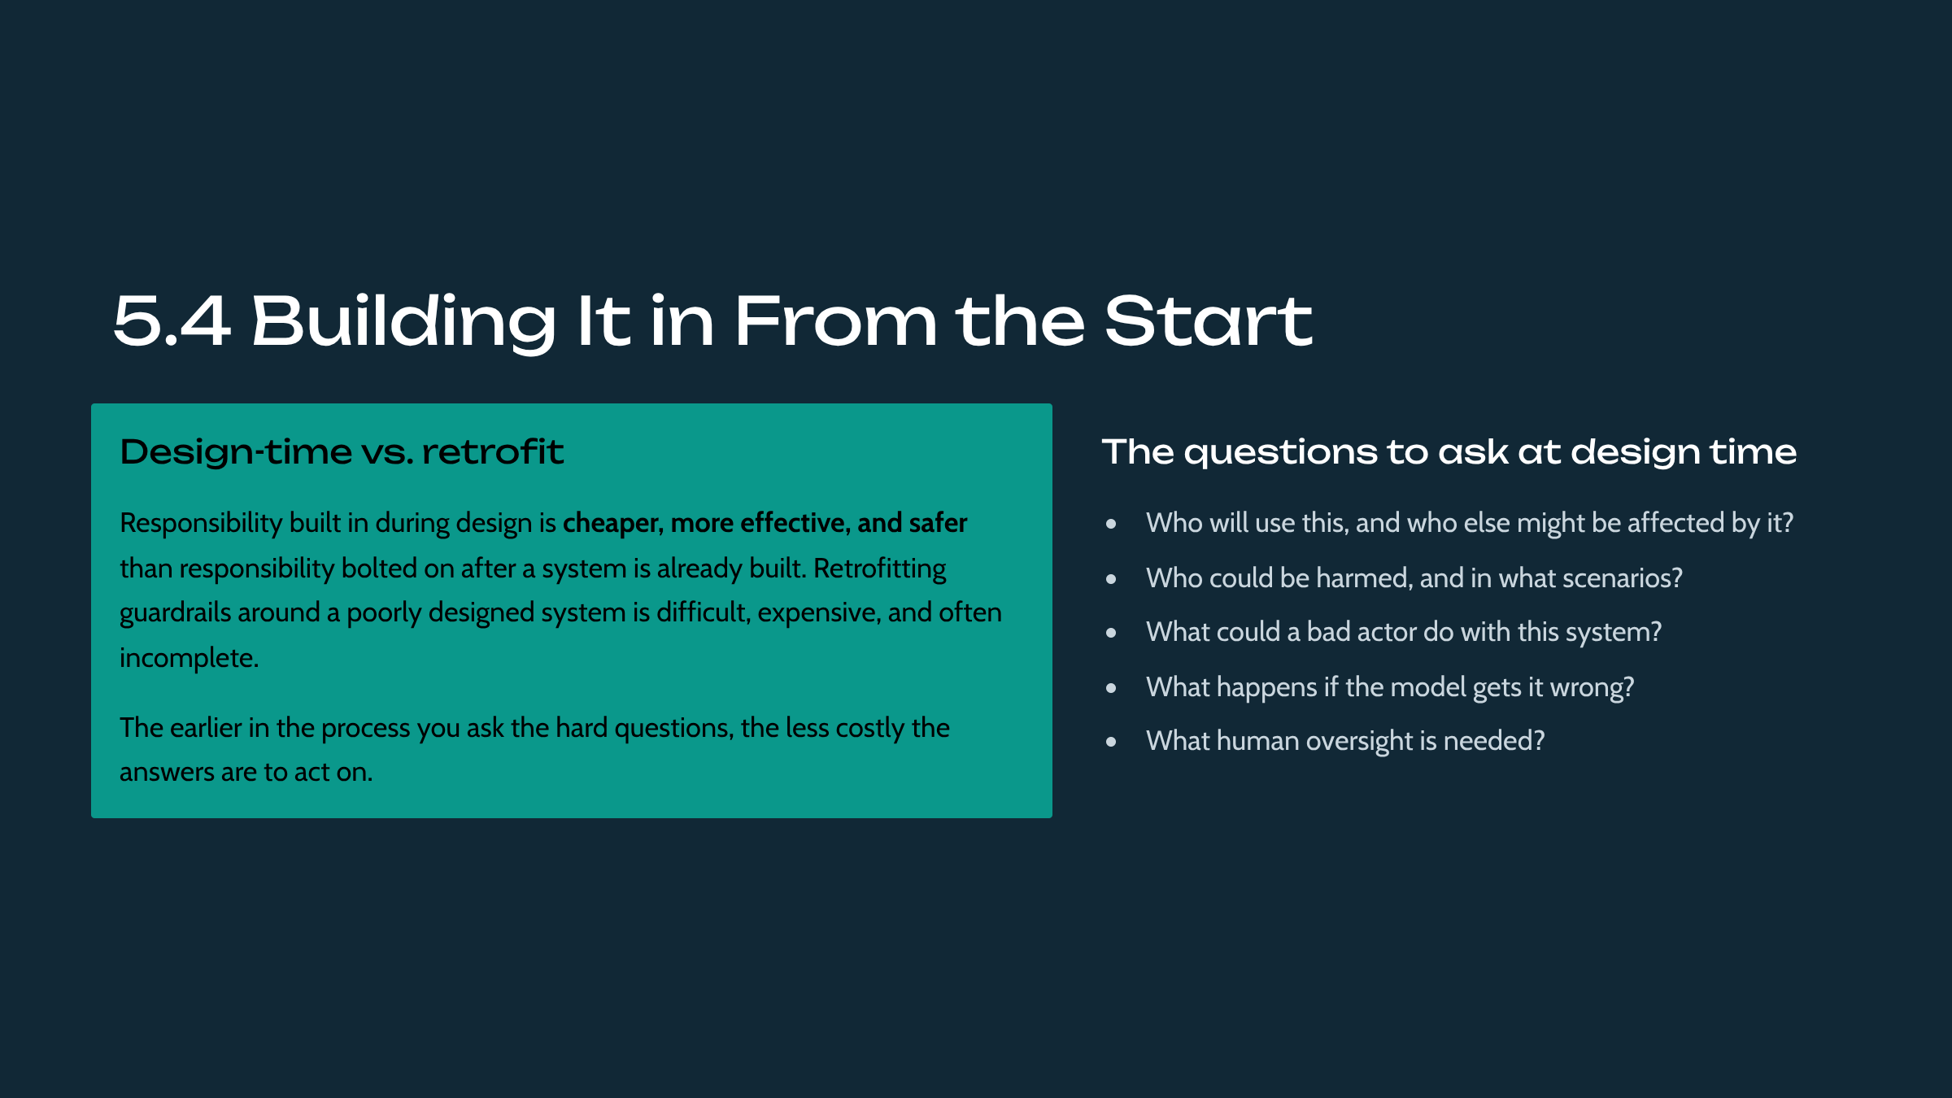

The central practical takeaway is to integrate responsibility at design time rather than retrofitting it. Asking early who could be harmed, and how, surfaces issues while they are still cheap to address. This 'build it in' principle is echoed across the catalogue, notably in the product and governance tracks.

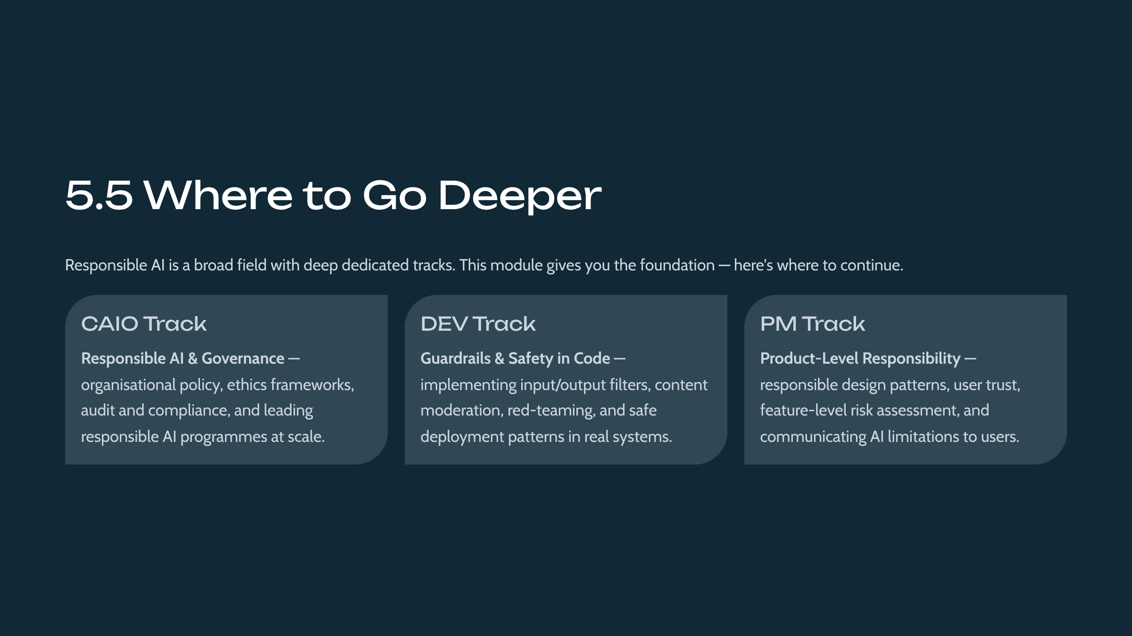

The final lesson points students to where responsibility is developed in depth: the Chief AI Officer track for governance and organizational risk, the developer track for hands-on guardrails and safety, and the product track for product-level responsibility. This closes the course by connecting the foundational stance to concrete next steps.

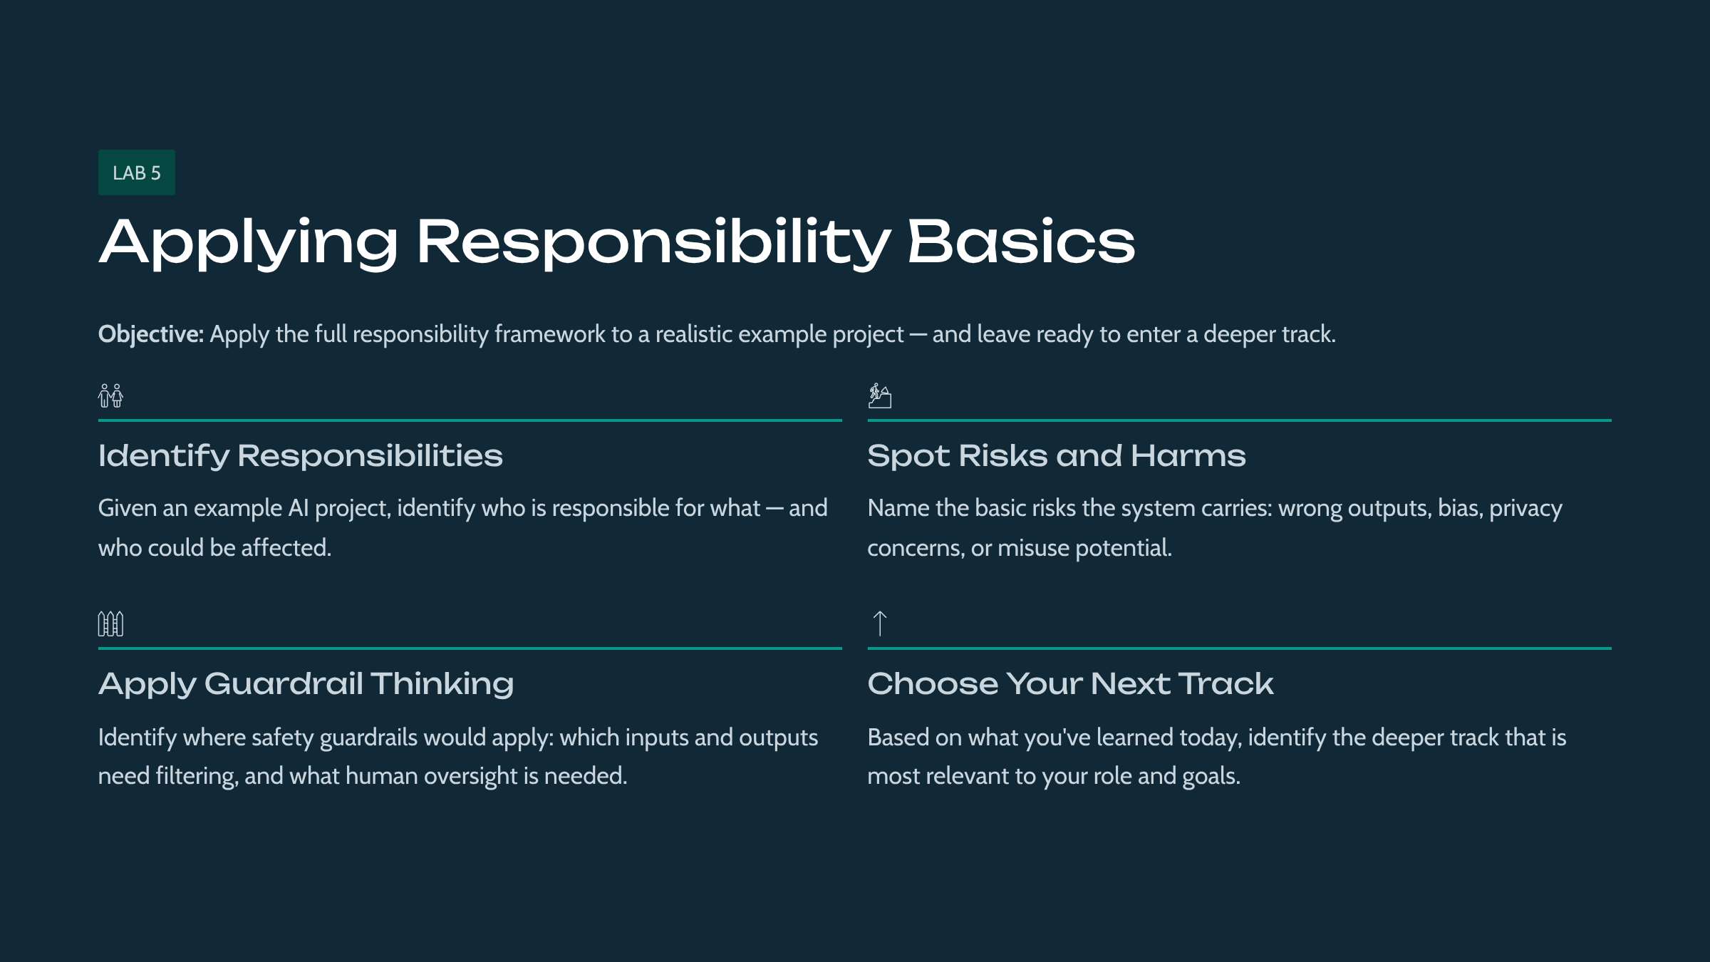

This lab gives students hands-on contact with the module's ideas. Students apply responsibility and safety basics to an example AI project and plan their next steps into the tracks. The detailed procedure is in the accompanying Lab Manual.

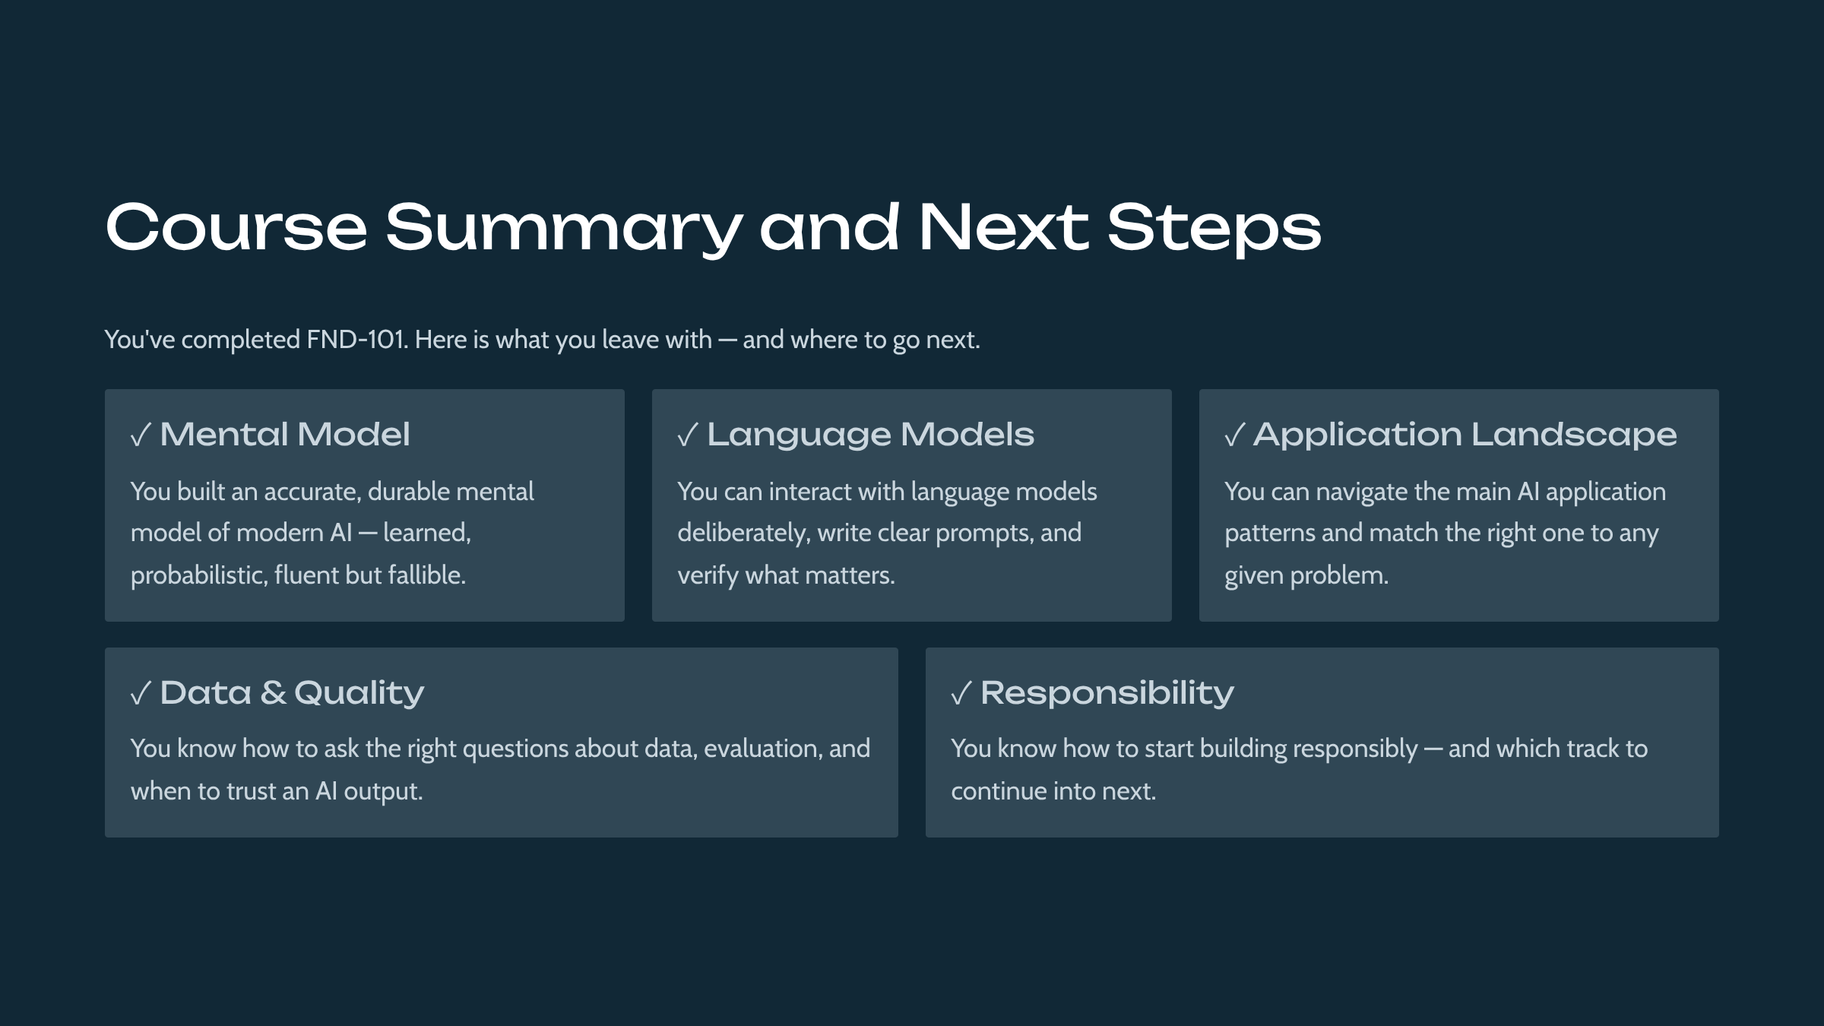

The summary revisits the five outcomes and reinforces that the foundational mental model is accurate and sufficient to support deeper study. It closes by prompting students to select their next track, completing the on-ramp's purpose of feeding the five specialist tracks.

